ATMO 170 In-class Optional Assignment Name_______________________________

Energy balance
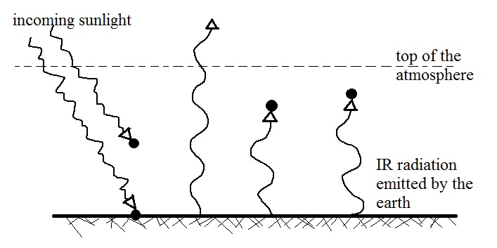
1. Now that we know that only about half of the incoming sunlight makes it through the atmosphere to the ground we can modify our simplified diagram of the atmospheric greenhouse effect as follows:

The atmosphere is absorbing three units (3 arrows) of EM radiation (1 from the sun and two units of IR radiation emitted by and coming from the earth's surface). To be in energy balance the atmosphere will need to emit 3 units of EM radiation. You will need to decide how many units to send upward and into space and how many to send downward to the ground (where you can assume it(they) will be absorbed). Draw the arrows in on the figure above.

To determine how the 3 units of IR radiation emitted by the atmosphere should be split up, look down at the ground where you will notice it is absorbing 1 unit and emitting 3 units. Look also up at the top of the figure (just above the top of the atmosphere) where you will see 2 arrows of sunlight arriving but only 1 arrow leaving the atmosphere and going back into space.

2. Here's a similar problem, another diagram that is not in energy balance. Draw in some arrows (no more than 2) and see if you can bring it into energy balance.
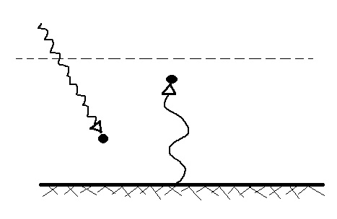

Humidity variables
1. A mixing ratio of 6 g/kg means there are 6 grams of _____________________________
mixed in with 1 kilogram of __________________________________.

2. If you know the air's temperature you can look up the value of the _______ in a table.
a. mixing ratio b. saturation mixing ratio c. relative humidity d. dew point

3. Adding water vapor to the air will not increase the _______.
a. mixing ratio b. saturation mixing ratio c. relative humidity d. dew point

4. 90º F air can potentially hold _______ times as much water vapor as 45º F air (consult the table on p. 86 in the photocopied ClassNotes)
a. 2 b. 4 c. 5 d. 10

5. To calculate the relative humidity you need to know the _______ and the _______.
a. mixing ratio b. saturation mixing ratio c. air temperature d. dew point

6. The value of the _______ will tell you whether moist air is saturated or not.
a. mixing ratio b. saturation mixing ratio c. relative humidity d. dew point

7. Based on the data in the figure below, does the parcel of 70º F air have MORE LESS or the SAME amount of water vapor than(as) the 85º F air?

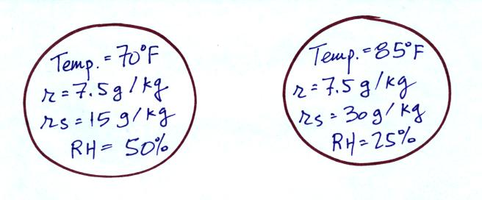

8. Which two of the following have the same job, telling you how much water vapor is actually in the air.
a. mixing ratio b. saturation mixing ratio c. relative humidity d. dew point

