ATMO 170A1 Optional Assignment Name________Answers_______________
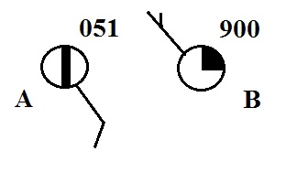
1. Is the sea level pressure at City A
905.1 mb or 1005.1 mb (circle the correct
value). What is the sea level pressure at City B?
The pressure at B is either 990.0 mb or 1099.0 mb.
Pick the one that is closer to average sea level
pressure - 1000 mb. Thus 990.0 mb is the correct answer.

2. The atmosphere is split into layers (troposphere, stratosphere, mesosphere, etc.) according to how _______ changes with altitude.
a. composition b. density c. pressure d. temperature
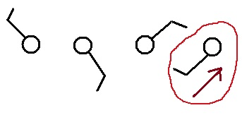

3. Circle the figure at right that shows winds
blowing from the southwest.

4. Would the 5 pm MST weather observations in Tucson be plotted on the 00Z 05Z 12Z or 17Z surface weather map? (note 5:00 pm is the same as 17:00)
Universal Time (aka Zulu or Greenwich Mean Time) is 7 hours later than MST
17:00 MST + 7:00 = 24:00 Z or 00 Z

5. Before being plotted on a surface weather map the measured station pressure must be corrected for
a. altitude b. latitude c. temperature d. time of day

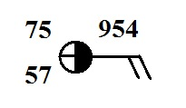
6. Show at right how the following weather observations would be plotted using the station model notation. This question wasn't corrected
temperature = 75º F cloud cover = 5/8
pressure = 995.4 mb dew point = 57º F
wind direction & speed = east at 20 knots

7. The top of an average thunderstorm would be around 10 km kilometers tall
(fill in the blank with 1 10 100 or 1000) 10 km is about 30,000 feet.
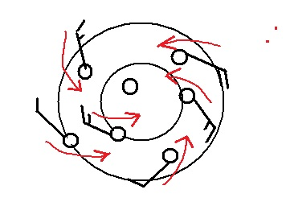
8. Does the figure at right show winds blowing in a
CLOCKWISE or COUNTERCLOCKWISE
direction? Are the winds CONVERGING or
DIVERGING? Does the figure show a surface
center of HIGH or LOW pressure.

9. Which of the following would not cause rising air motions?
a. low pressure center b. high pressure center c. cold front d. warm front

10 The term cyclone is just another name for a center of HIGH LOW pressure.

11. The large L symbol that you usually see on a surface weather map indicates a region of
a. low altitude b. low air density c. low air pressure d. low temperatures

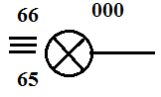
12. Use the weather data plotted at right to fill in the blanks
below. The X in the center circle means the sky is obscured. (include the correct units, some of the information
requested below may be plotted in the figure at right) This
question wasn't corrected (it would have taken too long)

temperature ___66 º F___ pressure ___1000.0 mb___
altitude _not given__ wind direction & speed __from East 1 - 2 knots__
present weather ___heavy fog____ dew point ____65º F____

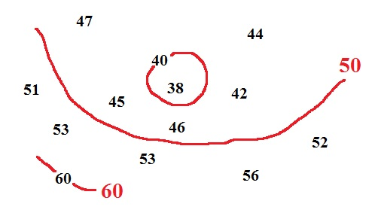
The relative humidity is not shown. Do the weather conditions give you any clue about what it must be? The heavy fog (which is obscuring the sky) and the fact that the air temperature and the dew point temperature are nearly equal means the relative humidity is close to 100%.

13. See if you can sketch in the 40º F and 50º F
isotherms on the figure at right. This question wasn't corrected because we worked it out in class

14. Are clouds more likely to form when moist air COOLS or WARMS, when moist air RISES or SINKS?

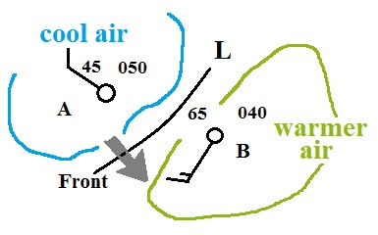
15. Weather conditions at two cities and a front are shown in the
figure at right. Would you expect the front to moving toward
CITY A or CITY B? Would this be a COLD or WARM
front. Fronts are like spokes on a wheel rotating counter-
clockwise around an axle of low pressure. This question
wasn't corrected

16. Find an example of each of the following
on the map drawn at right. This question wasn't corrected
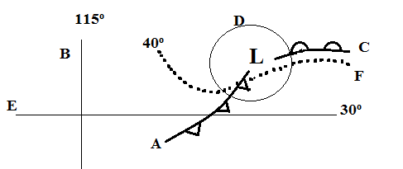
line of latitude____E______
warm front ____C______
isotherm ____F______
cold front ___A_______
isobar____D______
line of longitude ____B______

