ATMO 170 Name_________Answers_____________
In-class Optional Assignment
(due at the end of class)

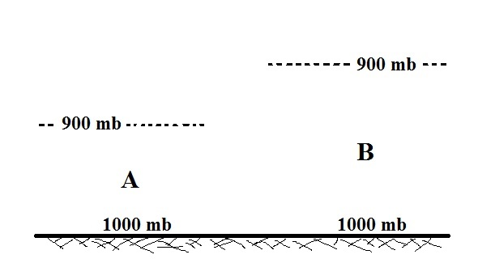

The pressures at sea level on both sides of the picture above are equal. That tells you the total amount (mass) of air between the ground and the top of the atmosphere is the same on both sides of the picture. The questions below focus on Layers A and B which just contain a portion of the air in the atmosphere. Layer A is thinner than layer B but there is a 100 mb drop in pressure between the ground and the top of both layers. Use that information to answer the following questions.

1. Is the amount (mass) of air in layer A GREATER than, the SAME as, or LESS than the amount of air in layer B?
Because pressure decreases by the same amount on both sides of the picture, the two layers have the same weights. The two layers must also have the same masses because weight depends on mass and gravity.

2. Is the rate of decrease of pressure with increasing altitude in layer A GREATER than, EQUAL to, or LESS than the rate in layer B.
The 100 mb drop in pressure occurs in a shorter distance in layer A than in layer B. That is a more rapid rate of pressure decrease with increasing altitude.

3. Is the density of the air in layer A GREATER than, the SAME as, or LESS than the density of the air in layer B.
Both layers contain the same mass of air. Layer A is thinner. It has smaller volume. Density is mass/volume. Layer A has smaller volume and higher density than
layer B.
4. Based on your answers above what relationship is there between the rate of pressure decrease with increasing altitude and air density?
The most rapid rate of pressure decrease with increasing altitude is occurring in the high density air in layer A

