ATMO 170 Name_____________________________________
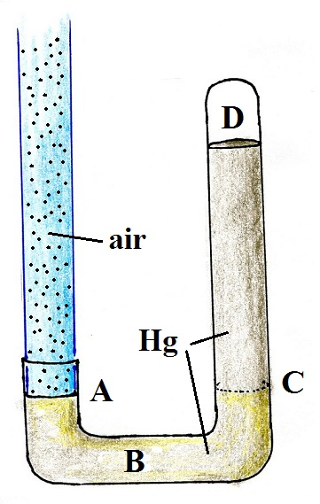
Optional Assignment (due at the end of class on Thu., Sept. 15)

1. The pressures inside the barometer at Points _______ and
_______ are the same. The pressure at Point _______ is zero.
(Hg in the figure is the chemical symbol for mercury)

2. If the strength of the earth's gravity were to increase would
the sea level atmospheric pressure INCREASE DECREASE
or remain the SAME. Would the reading on a mercury
barometer INCREASE DECREASE or remain the SAME.

3. It wouldn't be unusual to measure a pressure of 925 to 930 mb in Tucson. How would you explain this seemingly low value given that only the strongest hurricanes have pressures that low?

4. The oxygen concentration is still near 21% near the top of the stratosphere near 50 km altitude. Explain why you would not be able to survive there.

5. The atmosphere can be split into layers based on the vertical profile of
a. density b. ozone concentration c. pressure d. temperature

6. Which of the following does not belong in the same group as the other three?
a. flat anvil top on a thunderstorm b. cruising altitude in a commercial airplane
c. ozone layer d. top of Mt. Everest

7. Doubling the number of air molecules, doubling the volume, and doubling the temperature of air in a balloon will cause pressure to INCREASE DECREASE by a factor of TWO FOUR.

8. If you measured the air pressure and air temperature, you could use the ideal gas law to determine the
a. dew point temperature b. air density c. air's composition d. altitude

9. Air in the atmosphere generally behaves Charles' Law which means when you warm or cool a volume of air in the atmosphere, the air parcel DENSITY PRESSURE VOLUME will remain constant.

10. The total or net force exerted on a balloon by the pressure of the air surrounding the balloon is
a. down b. sideways c. up d. zero

