ATMO 170 Name____________Answers________________
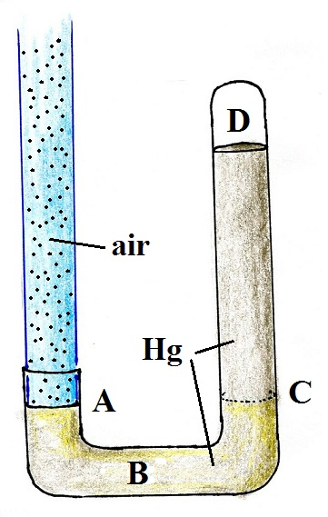
Optional Assignment (due at the end of class on Thu., Sept. 15)

1. The pressures inside the barometer at Points ___A___ and
___C___ are the same. The pressure at Point ___D___ is zero.
(Hg in the figure is the chemical symbol for mercury)
Points A and C are the two sides of the "balance." The weight of
everything above Point A is balanced by everything above Point C.
There is air above Point D. Nothing there to produce any pressure.

2. If the strength of the earth's gravity were to increase would
the sea level atmospheric pressure INCREASE DECREASE
or remain the SAME. Would the reading on a mercury
barometer INCREASE DECREASE or remain the SAME.
Pressure depends on the weight of the atmosphere. With an increase in the strength of gravity, the atmosphere would weigh more. But so would a column of mercury. The weight of a 30 inch column of mercury would still balance the weight of a very tall column of air extending from sea level to the top of the atmosphere.

3. It wouldn't be unusual to measure a pressure of 925 to 930 mb in Tucson. How would you explain this seemingly low value given that only the strongest hurricanes have pressures that low?
The low pressure in the center of a hurricane is at sea level. 925 to 930 mb is a very low sea level pressure reading (average sea level pressure is about 1000 mb).
The measurement in Tucson is made at about 2500 ft. altitude. That's why it is so low.

4. The oxygen concentration is still near 21% near the top of the stratosphere near 50 km altitude. Explain why you would not be able to survive there.
The air density would be too low. There just wouldn't be enough O₂ molecules in a breath of air to keep you alive.

5. The atmosphere can be split into layers based on the vertical profile of
a. density b. ozone concentration c. pressure d. temperature

6. Which of the following does not belong in the same group as the other three?
a. flat anvil top on a thunderstorm b. cruising altitude in a commercial airplane
c. ozone layer d. top of Mt. Everest
(a), (b), and (d) are all found around 10 km (about 30,000 ft.). The ozone layer is near 25 km high.

7. Doubling the number of air molecules, doubling the volume, and doubling the temperature of air in a balloon will cause pressure to INCREASE DECREASE by a factor of TWO FOUR.
This is best seen in a series of equations:

1st we right out the ideal gas law
P_{o} = N_{o} k T_{o} / V_{o}

Then we double N_{o}, T_{o}, and V_{o} and substitute into the equation to determine what the new pressure, P_{new}, will be:
P_{new} = (2 N_{o}) k (2 T_{o})/(2V_{o})

P_{new} = 4 N_{o} k T_{o}/2 V_{o}

P_{new} = 2 (N_{o} k T_{o} / V_{o}) = 2 P_{o}

8. If you measured the air pressure and air temperature, you could use the ideal gas law to determine the
a. dew point temperature b. air density c. air's composition d. altitude

9. Air in the atmosphere generally behaves Charles' Law which means when you warm or cool a volume of air in the atmosphere, the air parcel DENSITY PRESSURE VOLUME will remain constant.

10. The total or net force exerted on a balloon by the pressure of the air surrounding the balloon is
a. down b. sideways c. up d. zero
Pressure decreases with increasing altitude. The pressure pushing upward against the bottom of the balloon is a little stronger than the pressure pushing down on the top of the balloon. The overall effect is an upward pointing pressure difference force.

