Examples of questions that have appeared on quizzes in the past.

If you carried an object to the moon would its mass stay the SAME or CHANGE, would its weight stay the SAME or CHANGE, would its density stay the SAME or CHANGE.

Which of the following combinations would produce the highest density
a. large mass in a large volume b. large mass in a small volume
c. small mass in a large volume d. small mass in a small volume

If the earth's gravity were to suddenly double, but the amount (mass) of air in the atmosphere stayed the same, would sea level pressure INCREASE DECREASE or remain the SAME? Would the reading on a mercury barometer INCREASE DECREASE or remain the SAME?

Sea level atmospheric pressure is determined by the _______ of the atmosphere.
a. composition b. density c. temperature d. thickness e. weight
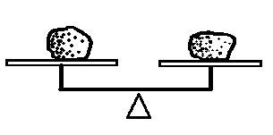

The fact that the two objects at right are balanced means
the two objects have the same _______ and _______.
a. composition b. density c. mass d. weight e. volume

If you multiply the mass of a pile of bricks by g (the gravitational
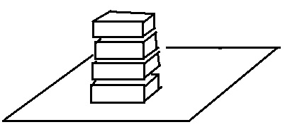
acceleration) you would get the ___________. Multiplying the
height of a pile of bricks times the area at the bottom of the pile
would give you the __________. Multiplying the density of a brick
times the volume of a pile of bricks would give you the __________. Dividing the weight of a pile of bricks by the area at the bottom of
the pile would be the __________. (fill in the blanks, each answer
below should be used once)
a. mass b. pressure c. volume d. weight

In 1648 Florin Perier carried a barometer to the top of the Puy de Dôme, a mountain in south central France. What do you think he was attempting to prove? (the experiment was probably mentioned in class in the semester this question appeared on a quiz. You can learn about the experiment at: http://backreaction.blogspot.com/2007/11/blaise-pascal-florin-p-and-puy-de-d.html)

