ATMO 170 In-class Optional Assignment Name_______________________________

Energy balance
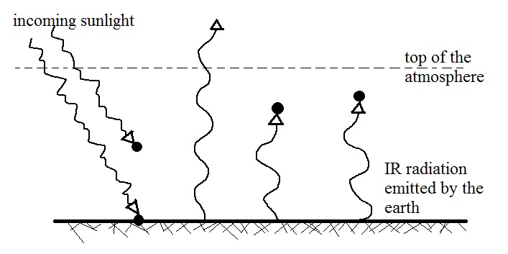
1. Now that we know that only about half of the incoming sunlight makes it through the atmosphere to the ground we can modify our simplified diagram of the atmospheric greenhouse effect as follows:

The atmosphere is absorbing three units (3 arrows) of EM radiation (1 from the sun and two units of IR radiation emitted by and coming from the earth's surface). To be in energy balance the atmosphere will need to emit 3 units of EM radiation. You will need to decide how many units to send upward and into space and how many to send downward to the ground (where you can assume it(they) will be absorbed). Draw the arrows in on the figure above.

To determine how the 3 units of IR radiation emitted by the atmosphere should be split up, look down at the ground where you will notice it is absorbing 1 unit and emitting 3 units. Look also up at the top of the figure (just above the top of the atmosphere) where you will see 2 arrows of sunlight arriving but only 1 arrow leaving the atmosphere and going back into space.

2. Here's a similar problem, another diagram that is not in energy balance. Draw in some arrows (no more than 2) and see if you can bring it into energy balance.
