1. Find the pattern in the column of numbers at left to estimate the relative humidities at right

Ta = 75 F, Td = 75 F, RH = 100% Ta = 55 F, Td = 35 F, RH is about__________%
Ta = 75 F, Td = 55 F, RH is about 50% Ta = 65 F, Td = 45 F, RH is about __________%
Ta = 75 F, Td = 35 F, RH is about 25% Ta = 95 F, Td = 35 F, RH is about __________%

2. Based on the information shown at right, does City A City B
CITY A or CITY B have the highest relative humidity. Ta = 90 F Ta = 70 F
Does the air in CITY A or CITY B contain the greatest Td = 60 F Td = 50 F
actual amount of water vapor?

3. The air temperature is 85 F, the pressure is 1000 mb, the mixing ratio is 10 g/kg, the dew point is 60 F, the saturation mixing ratio is 25 g/kg, the wind is blowing from the south at 15 MPH, and the time is 20:00 UT (Universal Time). What is the relative humidity?

4. To really wring the water vapor out of moist air would it be best to COOL or WARM the air?

5. Here's a solid question to test your understanding of the rain shadow effect.
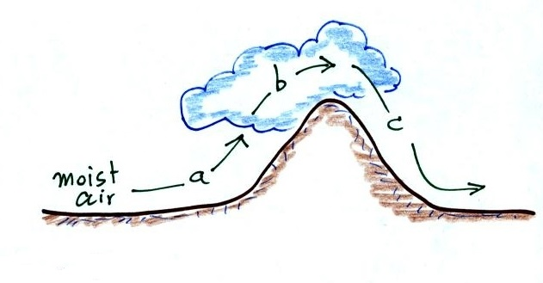
The mixing ratio, r, is increasing and RH is remaining constant _______
The RH is increasing & r is remaining constant _______
The mixing ratio, r, is decreasing and RH is remaining constant _______
The RH is decreasing & r is remaining constant _______
(fill in each blank with a, b, or c corresponding to the paths shown in the figure or
use d for nowhere; each answer should be used once)

6. Would the "drinking bird" work better on a DRY day, a HUMID day or does it
just NOT MATTER?

