This is not an Optional Assignment (there's no place for your name). It's something to do while you're sitting in class today. Hang onto this sheet. You'll be able to check your answers with answers online.

1. Use the results from the 2 example problems worked in class to come up with a general rule Example 1 Example 2
Ta = 90 F, RH = 20% Ta = 90, RH = 50%
Td = 70 F

Td = 45 F

General rule: When the difference Ta - Td is ___BIG____ the RH is ___LOW____.
When the difference Ta - Td is __SMALL___ the RH is ___HIGH____.
(fill in the first blank with BIG or SMALL, the second blank with HIGH or LOW. Note there are two correct answers to this question)
There is one situation where you can put in numbers:
When the difference Ta - Td is ____0_____ the RH is ____100%_____. (fill in each blank with a number)

2. Find the pattern in the column of numbers at left to estimate the relative humidities at right

Ta = 75 F, Td = 75 F, RH = 100% Ta - Td = 0 F RH = 100%
Ta = 75 F, Td = 55 F, RH is about 50% Ta - Td = 20 F RH = 100% / 2 = 50%
Ta = 75 F, Td = 35 F, RH is about 25% Ta - Td = 40 F RH = 100% / 2 = 50% / 2 = 25%

So I guess the pattern is that every time the Ta - Td difference increases by 20 F the RH is half of what it was. We can use that to figure out the relative humidities for the right hand column (shown below)

Ta = 55 F, Td = 35 F, Ta - Td = 20 F RH is about ____50___%
Ta = 65 F, Td = 45 F, Ta - Td = 20 F again RH is about ____50___%
Ta = 95 F, Td = 35 F, Ta - Td = 60 F RH is about ___12.5___%
In the last example RH = 100% / 2 = 50% / 2 = 25% / 2 = 12.5%

3. Based on the information shown at right, does City A City B
CITY A or CITY B have the highest relative humidity. Ta = 90 F Ta = 70 F
Does the air in CITY A or CITY B contain the greatest Td = 60 F Td = 50 F
actual amount of water vapor?
There's a 30 F difference between Ta and Td in City A and a smaller 20 F difference between Ta and Td in City B. The smaller Ta - Td difference in City B means it will have the highest relative humidity.
We learned that one of the jobs of the dew point is to give you an idea of the actual amount of water vapor that is in the air (just like the mixing ratio). City A has a higher dew point temperature than City B, therefore City A has the highest actual amount of water vapor in the air.

4. The air temperature is 85 F, the pressure is 1000 mb, the mixing ratio is 10 g/kg, the dew point is 60 F, the saturation mixing ratio is 25 g/kg, the wind is blowing from the south at 15 MPH, and the time is 20:00 UT (Universal Time). What is the relative humidity?
I purposely put in a lot of extraneous information. To calculate relative humidity, RH, you only need to know the mixing ratio, r, and the saturation mixing ratio, r_{s}.

RH = 100% x r/r_{s} = 100% x 10/25 = 100% x 2/5 = 100% x 0.4 = 40%

5. To really wring the water vapor out of moist air would it be best to COOL or WARM the air?
You need to cool the air to and then below the dew point temperature. As you cool the air below the dew point the air finds itself with more water vapor than it can contain. The excess water vapor condenses and is removed from the air.

6. Assume that no moisture is added to or removed from the air during the day. The ___RH___ will be highest in the morning, the ___Ta___ and ___r_{s}____ will be highest in the afternoon, and the __r____and ___Td___ will stay constant during the day. (fill in blank with mixing ratio (r), saturation mixing ratio (r_{s}), air temperature (Ta), dew point temperature (Td) or relative humidity (RH); each answer should be used once).
The mixing ratio tells you how much water vapor is actually in the air. Since moisture is not added or removed from the air mixing ratio will remain constant. Dew point has the same job as the mixing ratio. If you know the mixing ratio you can quickly determine the dew point and vice versa. So dew point also remains constant during the day. It's usually warmer in the afternoon than in the morning so Ta is highest in the afternoon. The value of the saturation mixing ratio depends on temperature, warm air has a higher saturation mixing ratio than cool air. So r_{s} is also higher in the afternoon. Cooling air increases the relative humidity (to 100% if you cool the air to the dew point). So the RH will be highest in the morning during the coolest part of the day.

7. Here's a solid question to test your understanding of the rain shadow effect.
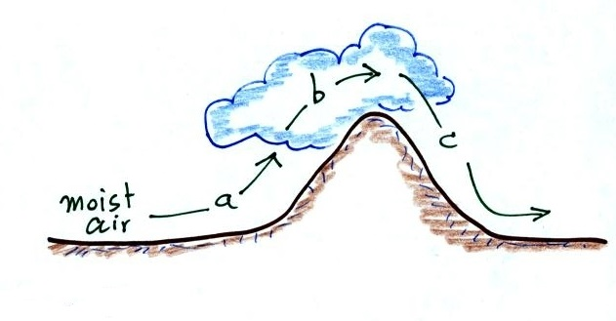
The mixing ratio, r, is increasing and RH is remaining constant ___d____
The RH is increasing & r is remaining constant ___a____
The mixing ratio is decreasing and RH is remaining constant ___b___
The RH is decreasing & r is remaining constant ___c___
(fill in each blank with a, b, or c corresponding to the paths shown in the figure or
use d for nowhere; each answer should be used once)
Moist unsaturated air is rising along path a. The air is cooling and the RH is increasing, but because the RH of the air hasn't reached 100% the air isn't losing water vapor so r remains constant.

Then a cloud forms indicating that the RH = 100%. The air continues to rise and cool along path b. You're cooling the air below its dew point and water vapor is condensing. The air is losing water vapor and r will decrease. RH remains at 100%.

Then the air reaches the summit and begins to descend and warm. Warming the air along path c will lower the RH but r will remain constant.

Water vapor isn't being added to the air anywhere in the picture. The mixing ratio doesn't increase anywhere in the picture.

8. Here's the relative humidity example problem we skipped in class
mixing ratio (r) = 10.5 g/kg relative humidity (RH) = 50%
what are the air temperature (Ta) and the dew point temperature (Td)?

This problem is worked out in the Tue., Oct. 28 notes. Ta = 80 F and Td = 60 F.

9. Would the "drinking bird" work better on a DRY or HUMID day or would does it
NOT MATTER? The head of the bird needs to be cooler than its tail in order to work. The cooling comes from evaporation of water on the birds beak. There'll be more net evaporation and more cooling on a dry day.

