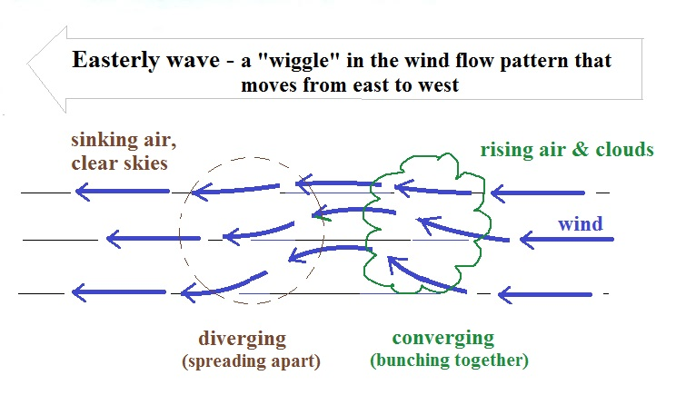
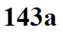

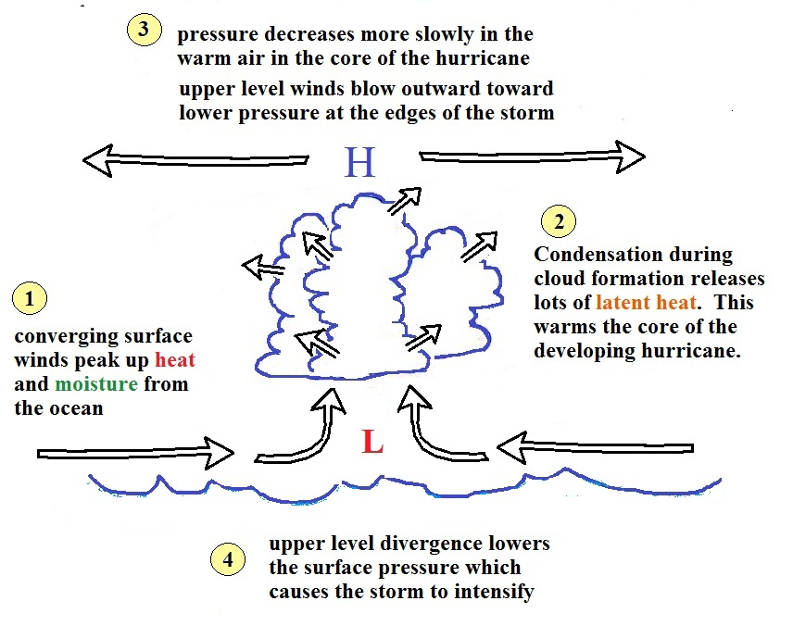
_____________________________________________________________________________________

Stages of development: (i) tropical disturbance
(ii) tropical depression
clear center of low pressure; rotating, 20 to 34 knot winds
(iii) tropical storm
25 to 64 knot winds, storm receives a name
(iv) hurricane
winds of 65 knots (74 MPH) or more

