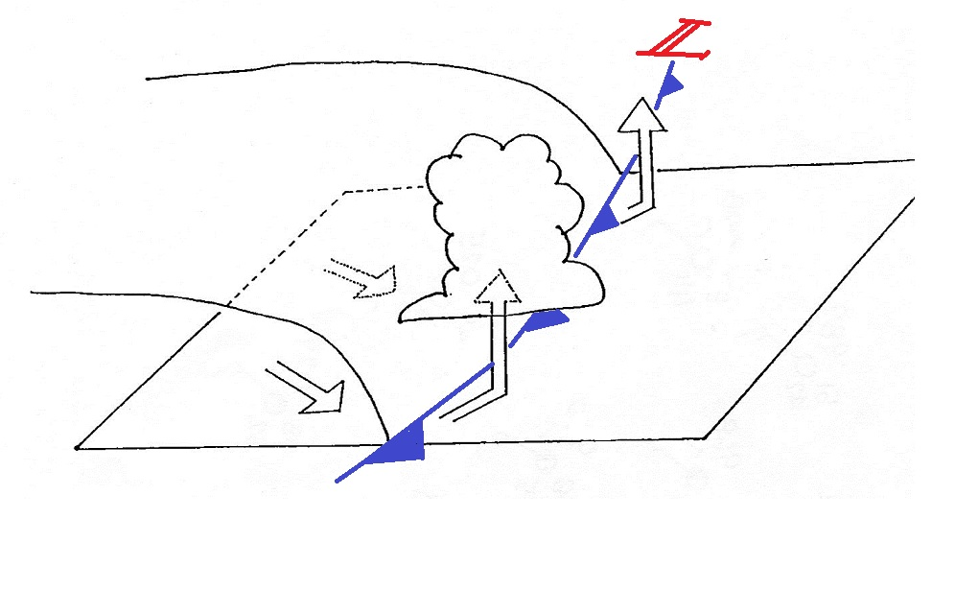
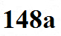
Weather changes preceding and following the passage of a cold front

Behind During Ahead

1. Temperature

2. Dew point

3. Winds

4. Clouds,
weather

5. Pressure
change

