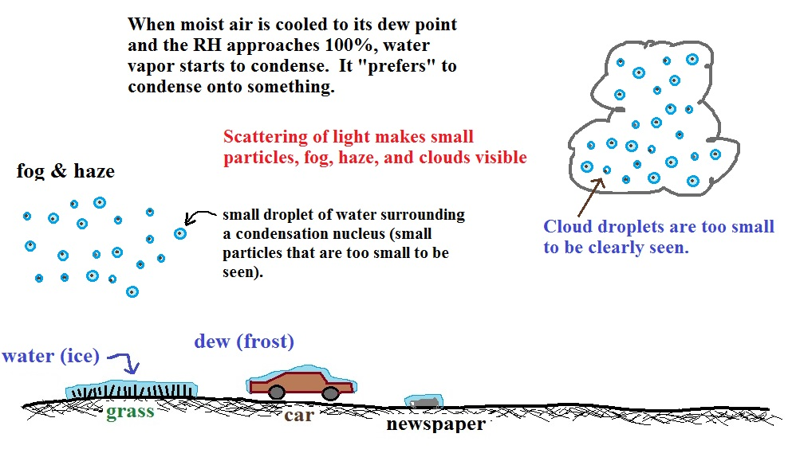
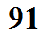
Condensation phenomena

Cloud condensation nuclei
When air above the ground is cooled to or below the dew point, it is much easier for water vapor to condense onto small particles in the air called cloud condensation nuclei (CCN) than to just form small drops of pure water.

CCN characteristics:
0.1 µm or more in diameter
100s per cm³ in clear air (summit of Mt. Lemmon in the winter)
1000s per cm³ in urban air

Condensation onto certain types of nuclei, hygroscopic nuclei, can begin to occur when the relative humidity is as low as 75%. Small salt particles, for example, act as hygroscopic nuclei.

