ATMO 170A1 Name_______________________________
In class Optional Assignment
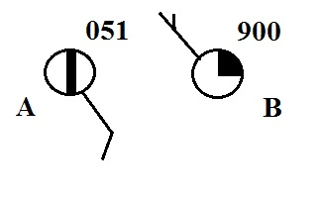
1. Is the sea level pressure at City A
905.1 mb or 1005.1 mb (circle the correct
value). Are there more clouds in the sky
at CITY A or at CITY B.

2. Before being plotted on a surface weather map the measured station pressure must be corrected for
a. altitude b. latitude c. temperature d. time of day
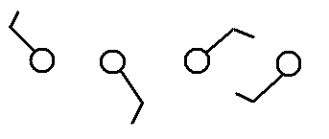
3. Circle the figure at right that shows winds
blowing from the southwest.

4. Would the 5 pm MST weather observations in Tucson be plotted on the 00Z 05Z 12Z or 17Z surface weather map?
00Z is midnight, 05Z is 5:00 am, 12Z is noon, and 17Z is 5:00 pm.
There is a 7 hour time zone difference between MST and Zulu time.

5. Show at right how the following weather observations would be plotted using the station model notation.
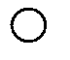
temperature = 75º F cloud cover = 1/8
pressure = 995.4 mb dew point = 57º F
wind direction & speed = east at 20 knots

6. Which one of the following would not cause rising air motions?
a. low pressure center b. high pressure center c. cold front d. warm front
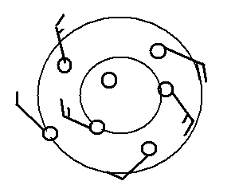
7. Does the figure at right show winds blowing in a
CLOCKWISE or COUNTERCLOCKWISE
direction? Are the winds CONVERGING or
DIVERGING? Does the figure show a surface
center of HIGH or LOW pressure.

8 The term cyclone is just another name for a center of HIGH LOW pressure.
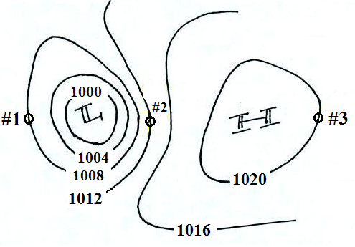

9. Determine the wind direction at each of the
3 points in the figure at right. Would the
fastest winds be found at Pt. #1 #2 or #3?
Would the warmest air
be found at Pt. #1 #2 or #3?
10. The large L symbol that you usually see on a surface weather map indicates a region of
a. low altitude b. low air density c. low air pressure d. low temperatures

11. Are clouds more likely to form when moist air COOLS or WARMS, when moist air RISES or SINKS?

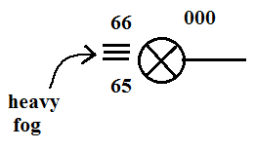
12. Use the weather data plotted at right to fill in the blanks
below. The X in the center circle means the sky is obscured. (include the correct units, some of the information requested below may be plotted in the figure
at right)

temperature __________ pressure ____________

altitude __________ wind direction & speed ___________ dew point ___________

The relative humidity is not shown. Do the weather conditions give you any clue about what it must be?
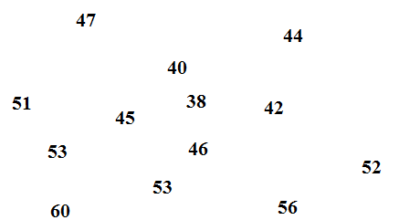
13. See if you can sketch in the 40º F and 50º F
isotherms on the figure at right.

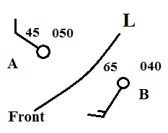
14. Weather conditions at two cities and a front are shown in the
figure at right. Would you expect the front to moving toward
CITY A or CITY B? Would this be a COLD or WARM
front.

15. Find an example of each of the following
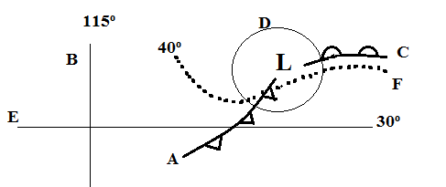
on the map drawn at right.

line of latitude__________
warm front __________
isotherm __________
cold front __________
isobar__________
line of longitude __________

