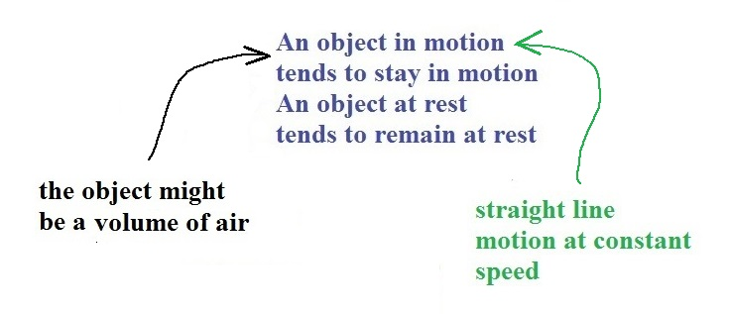
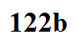
Newton's 1st law of motion goes something like this:

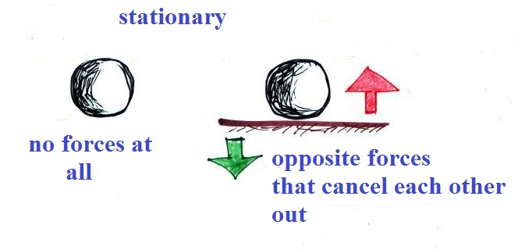
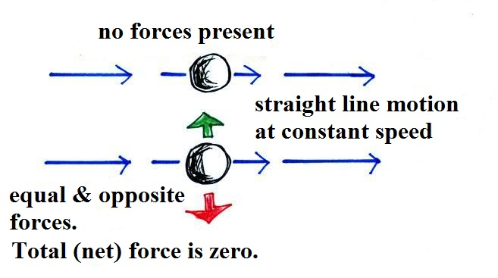
This is what happens when there is no net force - either no forces at all, or a situation where all the forces present cancel each other out.

Is there a net force in each of the following situations? If so what direction does it point?
