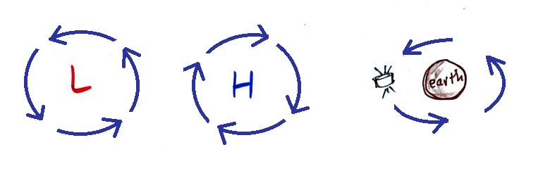
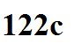
What about circular motion as shown below?

Wind blowing at constant speed around a satellite orbiting
centers of Low and High pressure the earth

Even if the speed is constant there must be a net force because the motion is not in a straight line. Does the net force point inward, outward, or in the direction of motion?

My sister can help answer that question. She owns and trains Arabian horses.
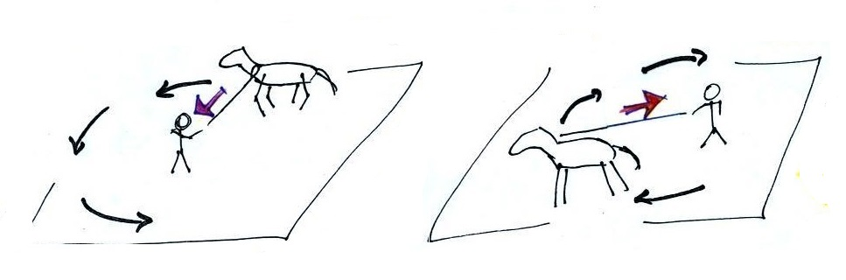

Here she's longing one of her horses, teaching it to move in a circle in both clockwise and counterclockwise directions. It's not something the horse really wants to do and my sister must continually pull inward on the lunge line to keep the horse from running off somewhere else.

A net inward force is needed to keep any object moving in a curved or circular path

What is the direction of the net force in each of the cases shown below?
