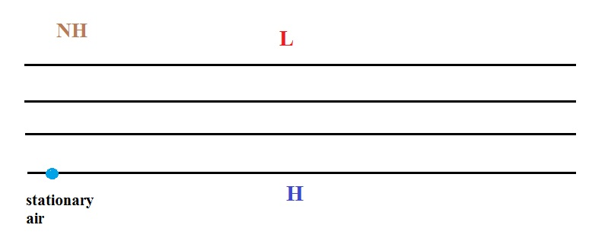
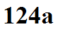

_____________________________________________________________________________________
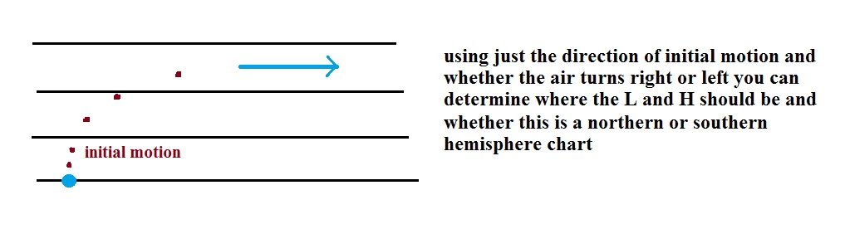
A simpler way of visualizing what we just worked out:




