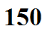
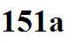
Thunderstorms come in many shapes, sizes, and levels of severity

ordinary single-cell severe supercell
thunderstorms thunderstorms thunderstorms

clusters or groups of thunderstorms

mesoscale convective system (MCS)

