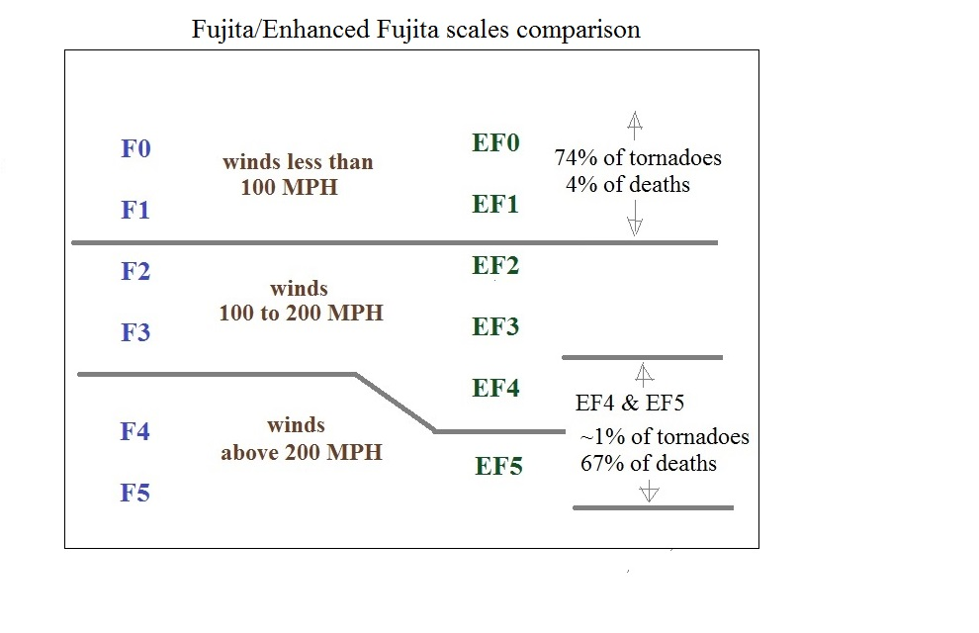
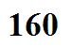
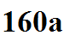
Wind speeds and the types of damage they would cause to an ordinary 1 or 2 family home
degree of damage | description | approximate  wind speed (MPH)
1 | visible damage | 65
2 | loss of roof covering material | 80
3 | broken glass in doors & windows | 95
4 | lifting of roof deck, loss of more than 20% of roof material, collapse of chimney, garage doors collapse inward, destruction of porch roof or carport | 100
5 | house slides off foundation | 120
6 | large sections of roof removed, most walls still standing | 120
7 | exterior walls collapse (top story) | 130
8 | most interior walls collapse (top story) | 150
9 | most walls in bottom floor collapse except small interior rooms | 150
10 | total destruction of entire building | 170

