
One of the problems with thinking that pressure is the weight of the atmosphere is that you're left with the idea that air pressure is just a downward force.

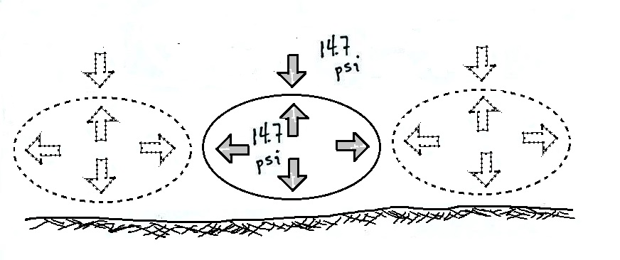

An air layer at the ground is compressed by the weight of the whole atmosphere above. The air layer isn't completely flattened. Air pushes upward with enough force that it is just above to support the weight of the air above. The air in the layer does push downward on the ground (the ground pushes back with the same strength). The air in the layer also pushes sideways. If you split the layer into lots of adjacent volumes you can see that the sideways push of one volume balances the sideways push (in the other direction) from the balloon alongside.

