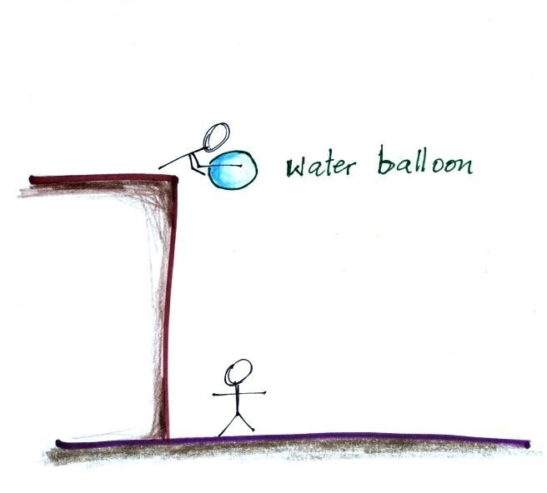
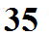

The water balloon in the figure at left will fall because of gravity. Large forces due to the pressure of the air surrounding the balloon are pushing upward, downward, and sideways on the balloon. Even though they are strong forces, they mostly cancel each other out. The downward force of gravity is almost unopposed.

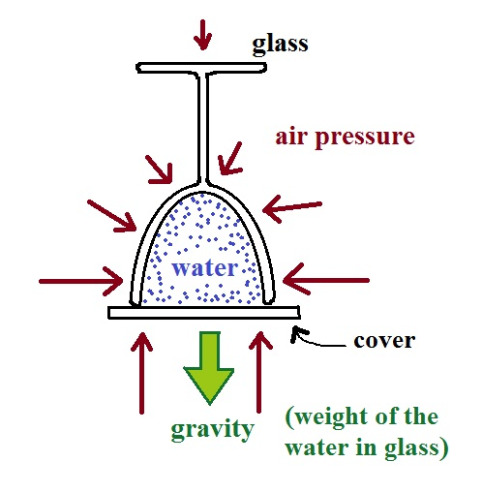
We can put the same amount of water in a wine glass,
cover the glass, and then turn it upside down. The water stays put. The same forces are still present. Air pressure is pushing down and sideways on the glass but not on the water inside.

Air pressure is also pushing upward on the cover that keeps the water in the glass. The upward air pressure force is not being used to cancel out the downward air pressure force (as it was with the water balloon). All of the upward air pressure force is being used to counteract the downward pull of gravity. Because the air pressure force is stronger than gravity it is able to keep the water from falling out of the glass.

