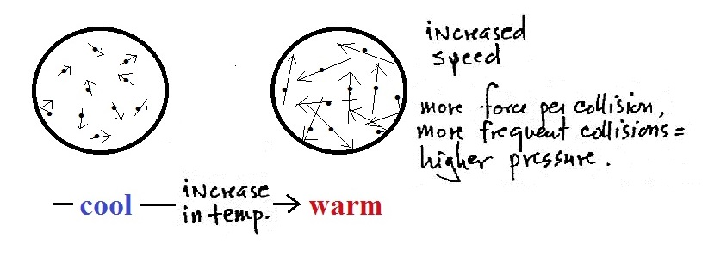
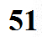
3. Temperature, T, is a measure of the average speed of the gas molecules
P is directly proportional to T (the absolute or Kelvin scale must be used so that temperature is never less than zero).
4. Mass of the molecules?
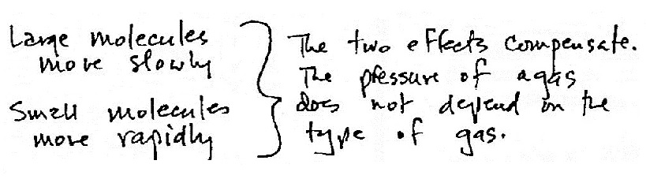

The ideal gas law equations summarize the dependence of P on N, V, and T.
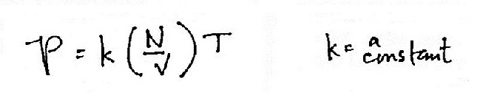

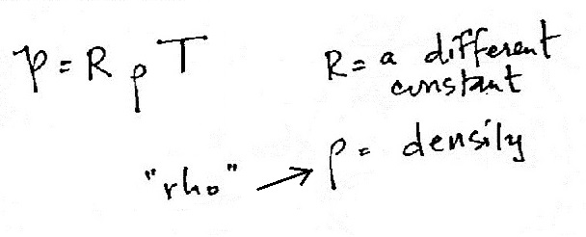

alternate form

