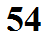
Charles' law demonstration
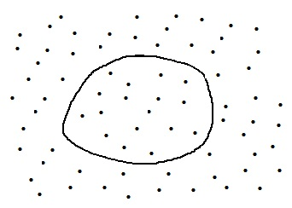
Start with a balloon filled with air. The
temperature (T) and density (ρ) inside and outside the balloon are the same. A balloon is flexible and will change size in order to keep the pressures inside and outside equal.

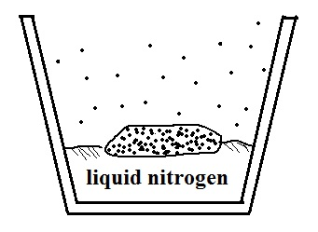
Next we will cool the balloon (a lot) by dunking it into liquid nitrogen. As the air cools, the pressure in the balloon decreases momentarily. This creates a pressure imbalance - the outside air pressure compresses the balloon. The reduction in balloon volume increases the air density which raises the pressure inside the balloon. The balloon will continue to shrink in size until its pressure is again the
same as the surrounding air. We end up with a small balloon filled with cold, high density air.
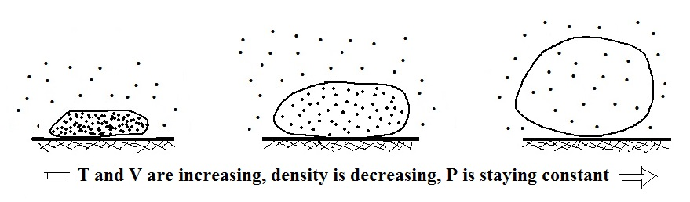

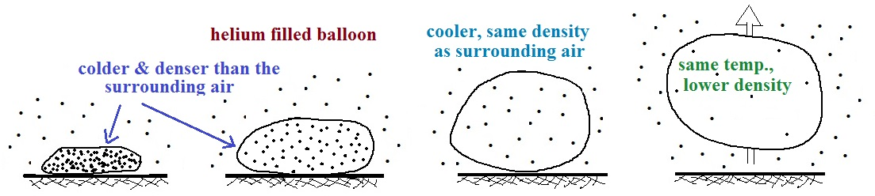
Once we remove the balloon from the liquid nitrogen it will begin to warm and we will see the process in reverse.

We can repeat the demonstration with a balloon filled with helium, which is less dense than air. The density of the cold helium will be higher than the surrounding air. As the balloon warms it will reach a point where its density is equal to that of the air (the helium is still cooler than the air and is neutrally buoyant, weightless, at this point). Eventually the helium warms to the same temperature of the air where is it again less dense than air and floats upward from the table top.

