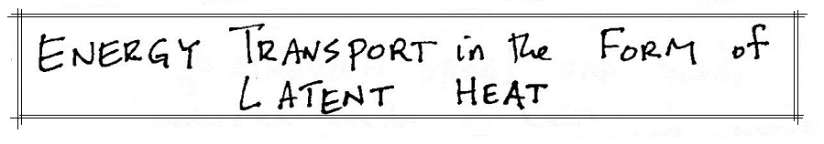
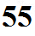

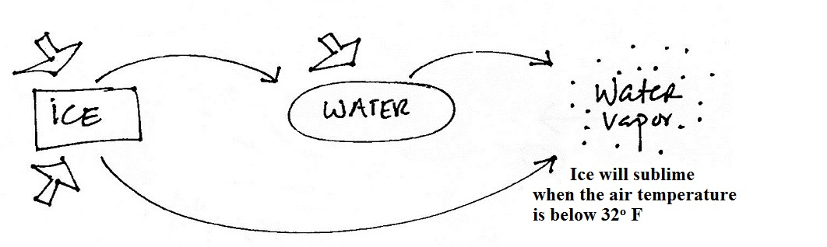
You need to ADD ENERGY to cause the phase changes below to occur. You can boil (evaporate) water for example by placing a pan of water on a stove and turning on the burner. Energy will naturally flow from the hot burner to the pan of water. It might not be obvious where the needed energy is coming from. A piece of ice left on a table in a warm room will melt. The energy in this case is TAKEN from the surroundings (cooling the surroundings).

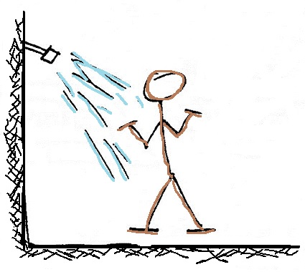

Phase changes sometimes occur "whether we
want them to or not." Energy must be added to water in order for it to evaporate. In this example the energy is taken from your body. You feel cold as a result.

