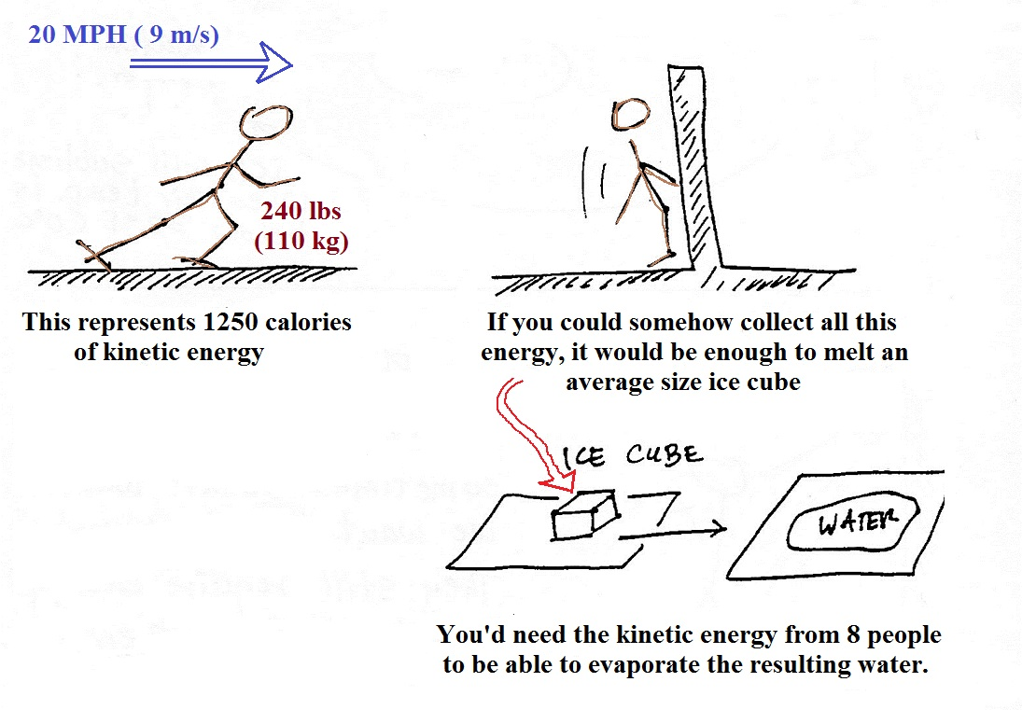
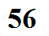
There are enormous amounts of energy involved in phase changes.

