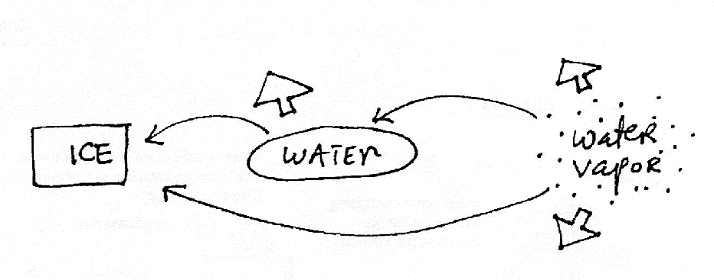
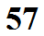
In order for the phase changes below to occur, ENERGY is REMOVED.
You place water in a freezer. Energy naturally flows from the water to the colder surroundings in the freezer. When enough has been lost by the water, the water freezes. Phase changes like these occur without you actively playing a role. Energy is RELEASED into the surroundings (warming the surroundings.
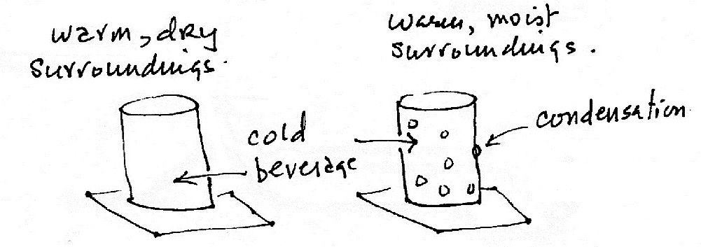
Two beverage cans have just been taken out of a refrigerator and placed on a table in a warm room. Will both cans warm up at the same rate or will one warm up more quickly than the other? You can assume that both cans have the same temperature and that the temperature of the air surrounding both cans is the same.

