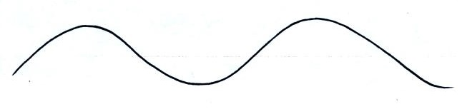
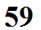
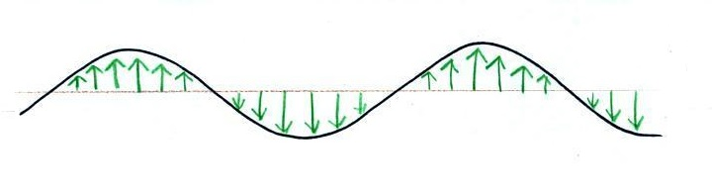
Many textbooks depict electromagnetic (EM) radiation like this, as a wavy line. They don't always explain what the wavy line represents.
The wavy line connects the tips of a bunch of "electric field" arrows (vectors), the green arrows above. But then the questions becomes what are electric field arrows?

An electric field arrow (vector)
just shows the direction and
gives you an idea of the strength
of the electrical force
that would be exerted on a positive charge at that position.

