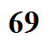
Filter absorption curve for the earth's atmosphere (simplified version)

