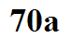
Radiative equlibrium on the earth without an atmosphere
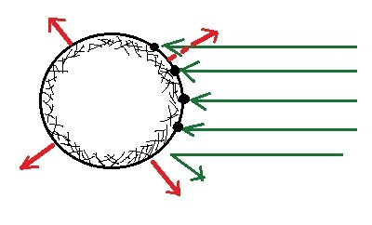
Outer space view Viewed from the ground
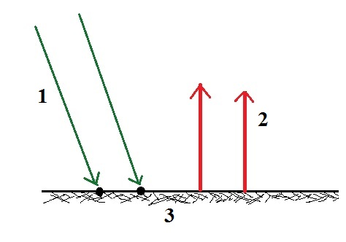

4 units (arrows) of energy absorbed is
balanced by 4 units going out. 2 units of energy absorbed is balanced by 2
units going out. 2 units instead of 4 are
shown to keep the figure as simple as possible.

