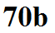
Radiative equilibrium on the earth with an atmosphere that contains greenhouse gases (simplified view of the greenhouse effect)
