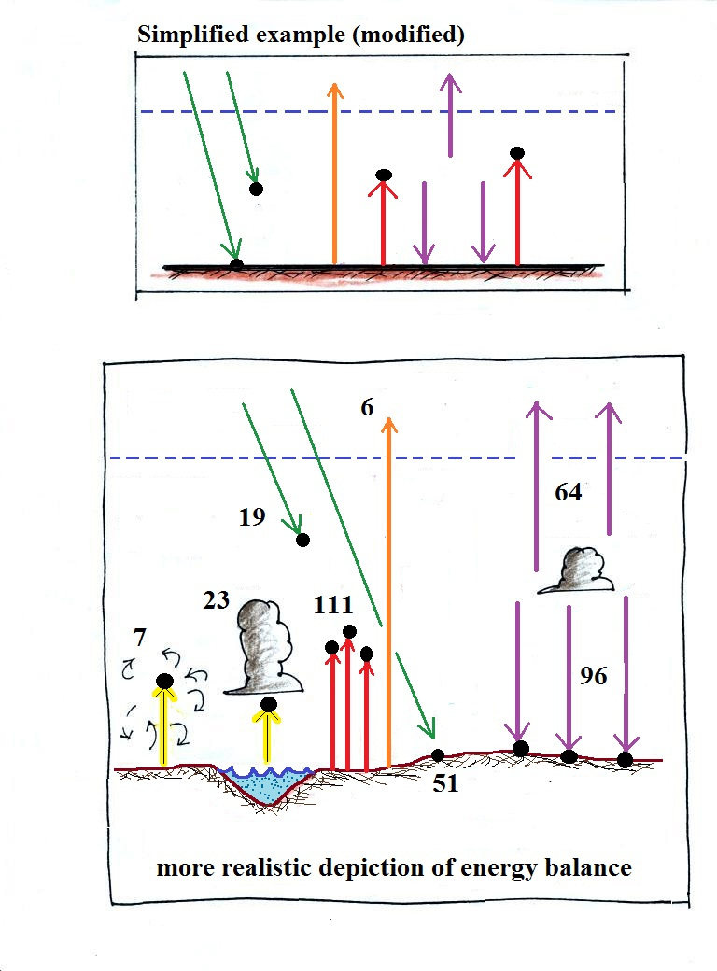


In the lower figure, is the energy arriving at the earth equal to the amount of energy leaving the earth and going back out into space?
Is the amount of energy being absorbed by the atmosphere balanced by an equal amount of emitted energy.
Is the ground absorbing and losing equal amounts of energy?
There are 2 or 3 other surprising things to notice in the realistic energy balance depiction.

