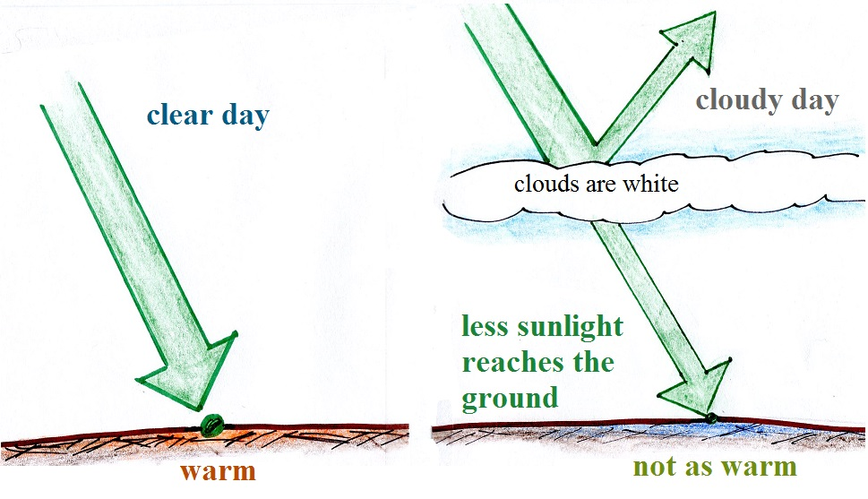
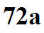
During the day, clouds reflect visible and near IR light. This reduces the amount of solar energy reaching the ground and means the ground won't warm as quickly or get as hot as it would on a clear day.
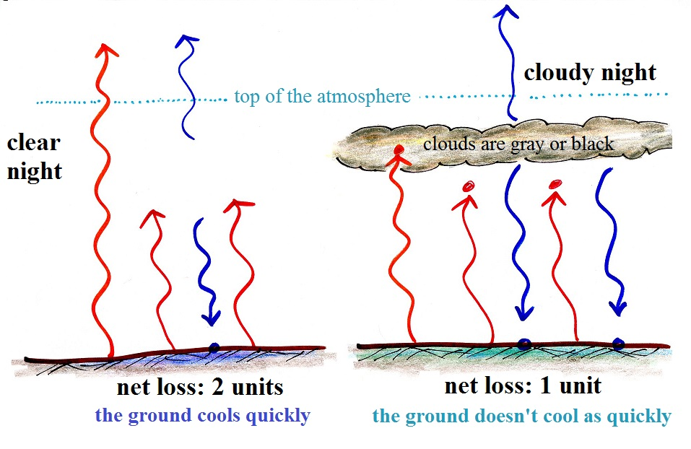
At night, the ground cools because it is emitting far IR radiation. Clouds absorb and return (emit) some of this energy back to the ground. The ground doesn't cool as rapidly or get as cold on a cloudy night as it would on a clear night.

