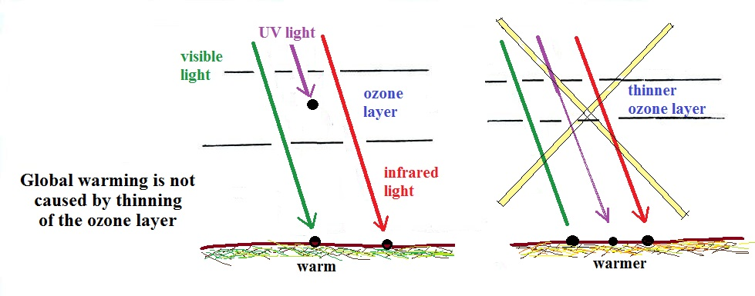

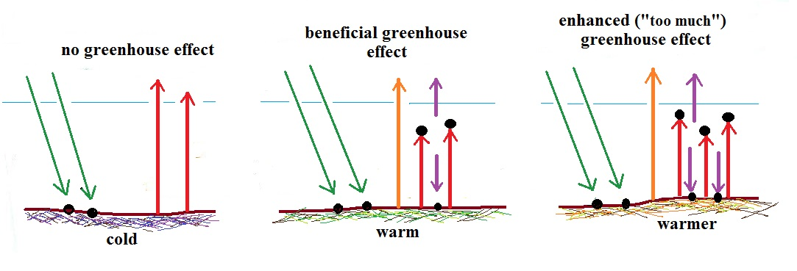
Thinning of the ozone layer will allow additional UV light to reach the ground. That will increase the incidence of skin cancer, cataracts, and that sort of thing. There is not enough energy in the increased UV reaching the ground to cause global warming however.


It is increasing concentrations of greenhouse gases that are of concern. Without any greenhouse gases the earth global annual average temperature would be quite cold, around 0º F. A beneficial concentration of greenhouse gases increases the global average temperature to about 60º F. It seems reasonably that adding more greenhouse gases to the air will cause additional warming. How much warming and what the consequences of that warming will be are still unknown.

