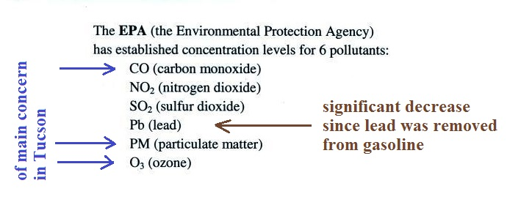
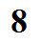

Rather than reporting measured concentrations, an Air Quality Index (AQI) is used instead
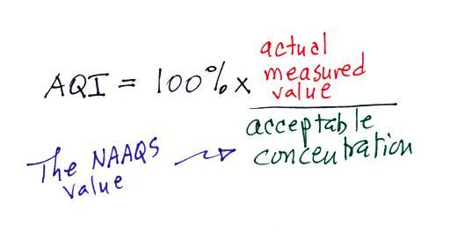

The acceptable concentration levels are known as the National Ambient Air Quality Standards (NAAQS). The values differ depending on the particular pollutant.

The NAAQS values for carbon monoxide are:
9 ppm (average over an 8 hour period)
35 ppm ( average over a 1 hour period)
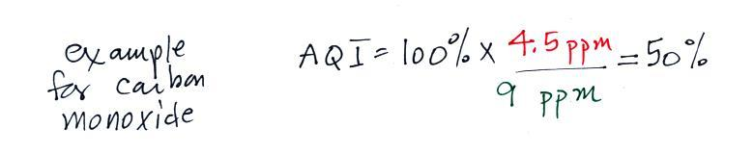

Index value Air Quality Index value Air Quality
0 to 50 Good 101 to 150 Unhealthy for sensitive groups
51 to 100 Moderate 151 to 200 Unhealthy
201 to 300 Very unhealthy
301 to 500 Hazardous

