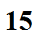
Photochemical (Los Angeles type) Smog

Ozone production (at ground level)

N₂(g) + O₂(g) +high temperature ---> 2NO(g) nitric oxide

2NO(g) + O₂(g) ---> 2NO₂(g) nitrogen dioxide

NO₂(g) + sunlight ---> NO(g) + O(g) atomic oxygen

O(g) + O₂(g) ---> O₃ (g) ozone
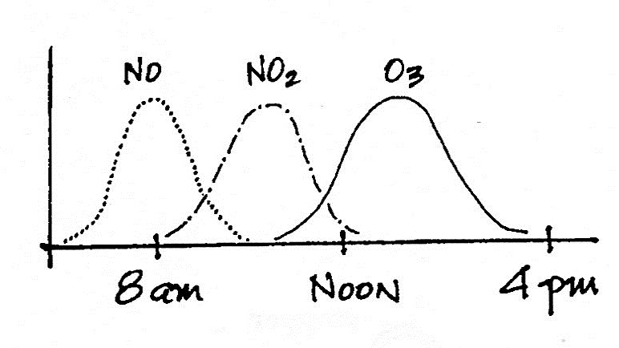

Ozone is a secondary
pollutant

Ozone (and photochemical smog)
are summer afternoon pollutants

Ozone aggravates respiratory diseases, is harmful to plants, and damages rubber and rubber like materials.

The American Lung Association's 2018 State of the Air report mentions that 11 of the 25 cities with the highest ozone concentrations are found in California (Los Angeles is at the top of the list). Two cities are found in both Texas and Colorado, one each in Arizona (Pheonix), Utah, and Nevada. You can find a link to the State of the Air report and a complete list of the 25 cities with the highest O₃ levels in the online lecture notes.

