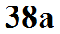
Pressure data
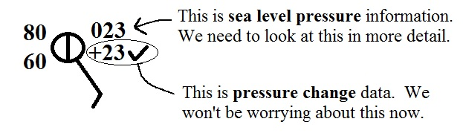

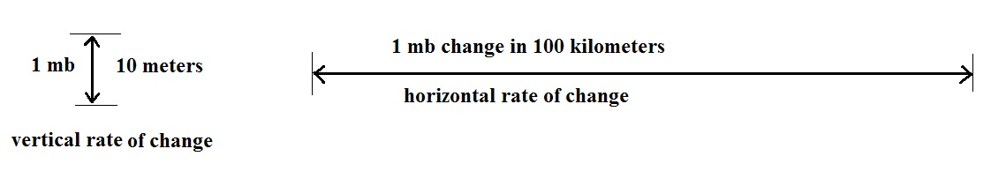
The pressure value plotted on a surface map starts with a measurement at a particular city or location. This is called the station pressure. Then an altitude correction is made. This is necessary because pressure changes much more rapidly in a vertical direction than it does when moving horizontally. Typical rates of change are shown below.
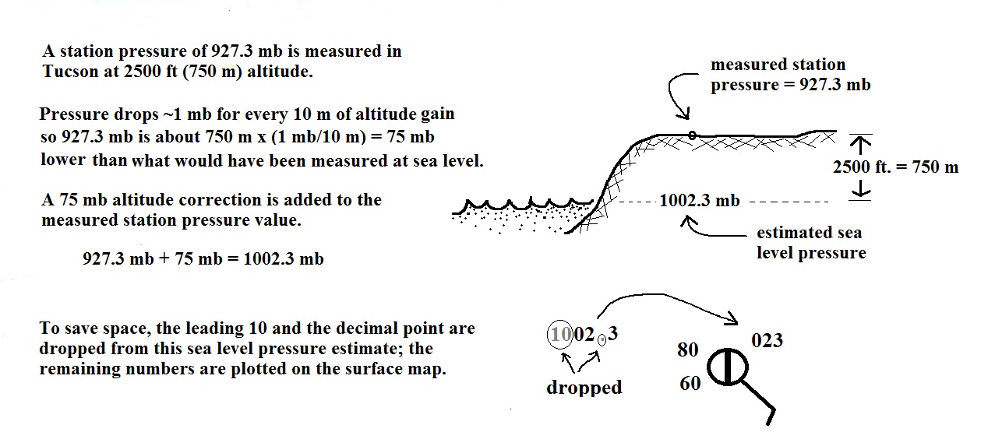
Meteorologists hope to map out small horizontal pressure differences on a surface map. It is small horizontal differences in pressure that cause the wind to blow and create storms. If corrections for altitude were not made, the large vertical changes in pressure caused by altitude would dominate and would completely hide the horizontal pressure variations.

