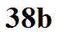
Coding pressure (remove the leading 9 or 10 & the decimal point)
1011.6 990.0
988.6 1000.0
Decoding station model pressure data (add a leading 9 or 10 & a decimal point)
131
999
110
800

Time (maps are usually draw at hourly intervals)
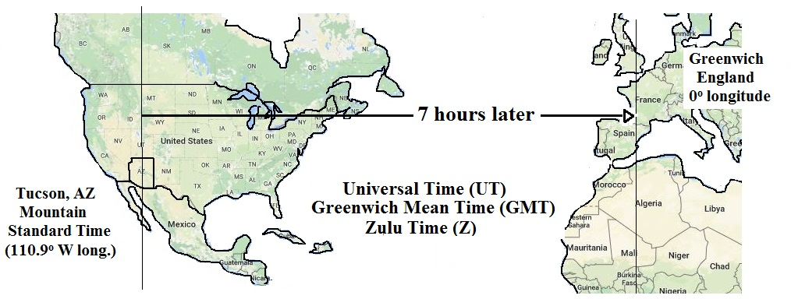
Examples
9 am MST:
add the 7 hour time zone correction
9:00 MST + 7:00 = 16:00 Z (4 pm in Greenwich)

2:30 pm MST:
convert to the 24 hour clock by adding 12 hours then add the 7 hour time zone correction
2:30 pm MST = 14:30 MST 14:30 MST + 7:00 = 21:30 Z (9:30 pm in Greenwich)

15 Z subtract the 7 hour time zone correction
15:00 UT - 7:00 = 8:00 MST

