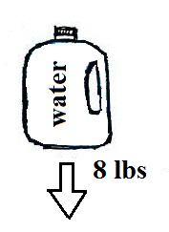
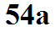
Archimedes law

A gallon of water weighs about 8 pounds (lbs).

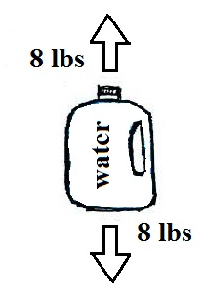
If you submerge the gallon of water in a swimming pool you would find that it is much lighter. Actually you would find that it was, for all intents and purposes, weightless.

Archimedes law explains why this is true. Archimedes
law goes something like this:
An object immersed in a fluid experiences an
upward buoyant force equal to the weight of
fluid displaced by the object.

A gallon bottle displaces a gallon of pool water. That means the
upward buoyant force is 8 lbs., the weight of the displaced
water. This upward buoyant force balances the 8 lb. downward force, the weight of the bottle.
The total force is zero, the bottle is weightless.

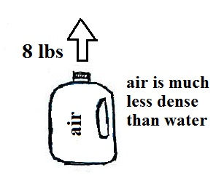
You can easily imagine what would happen if you
poured out all of the water, filled the bottle with air,
and tried to submerge the bottle in the pool. It
The bottle would try to float, it would be difficult to
carry it underwater. The bottle is still displacing a gallon of pool water so there is still an upward force of 8 lbs.. The air in the bottle weighs practically
nothing, so the downward force is practically nonexistent.

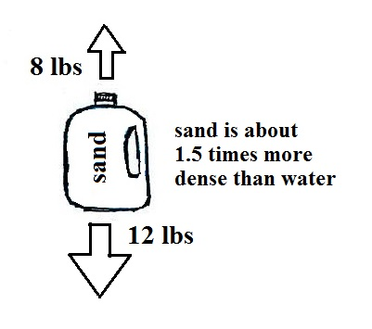
Now imagine filling the bottle with sand. I did
some quick measurements and found a gallon of
sand weighs about 12 pounds. If you submerge
a bottle of sand in water, the 12 pound weight of
the bottle is offset by the 8 lb. upward buoyant
force (the weight of the gallon of water displaced
by the bottle). The bottle is noticeably lighter in
the pool than it is out of the pool but it is still heavy
enough (a net 4 lb. downward force) to sink.

You can sum it all up this way: An object that is less dense than the fluid surrounding it (such as a bottle of air submerged in water) will float. An object that is dense than the surrounding fluid (sand surrounded by water) will sink. Something that has the same density as the fluid surrounding it will "hover."

