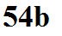
Instead of a 1 gallon plastic bottle immersed in a swimming pool we could imagine a 1 gallon volume of air surrounded by gases in the atmosphere. Archimedes' principle still applies.
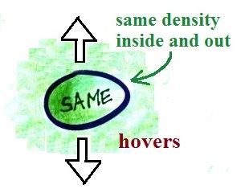

A balloon filled with air that has the same density as the
air around it would be weightless. The weight of the air
displaced by the balloon (upward buoyant force) is equal
to the weight of the air inside the balloon (downward force).
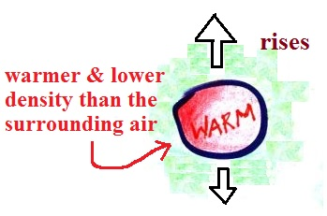

A balloon filled with (warm) low density air won't weigh as much as the air it displaces.
The upward force will be stronger than the downward force and the air will rise.

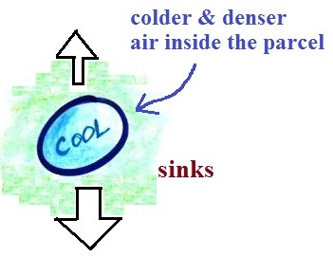

If the balloon is filled with (cold) high density air
it will weigh more than the air it displaces and will
sink.

