Monday April 20, 2009
Some unusual music today: Tchavo from Fishtank Ensemble.
The 1S1P Bonus Assignment was collected today. You can check on the progress of the 1S1P grading by clicking here. As people reach 45 pts (the max. no. of 1S1P points you can earn) I'll be adding their names to this list.
The Expt. #3 revised reports were collected today. The Expt. #4 revised reports are due next Monday (April 27). Please return the original report with your revised report.
There is an Optional Assignment that is due Wednesday this week.

We'll be spending most of the next two classes on tornadoes. Here's a particularly nice photograph of a wall cloud and a tornado ( from the University Corporation for Atmospheric Research ). A wall cloud is produced by the rotating updraft (mesocyclone) in severe and supercell thunderstorms. It is an extra little bit of cloud that extends below the rest of the base of the thunderstorm.
The tornado in the picture isn't very thick and is practically transparent, it is probably a relatively weak tornado (that doesn't mean it isn't dangerous).
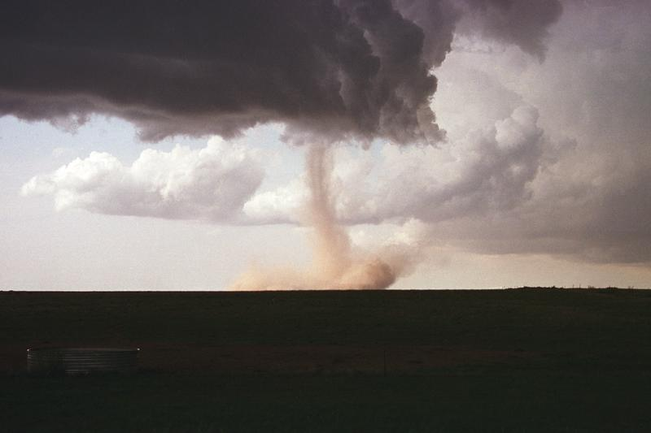

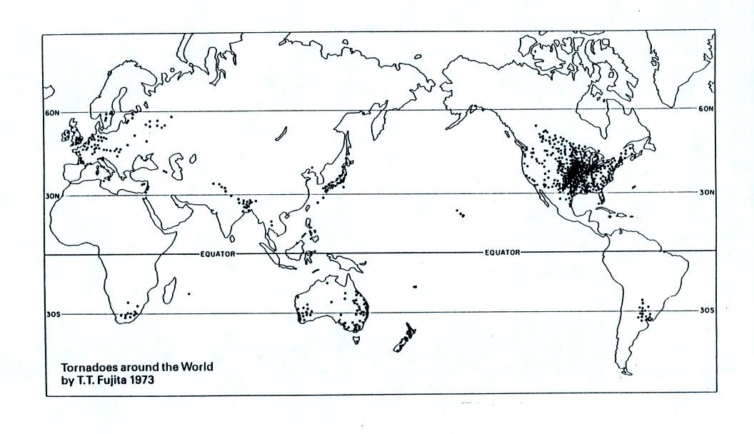
The United States has more tornadoes in an average year than any other country in the world (over 1000 per year). The central US has just the right mix of meteorological conditions.
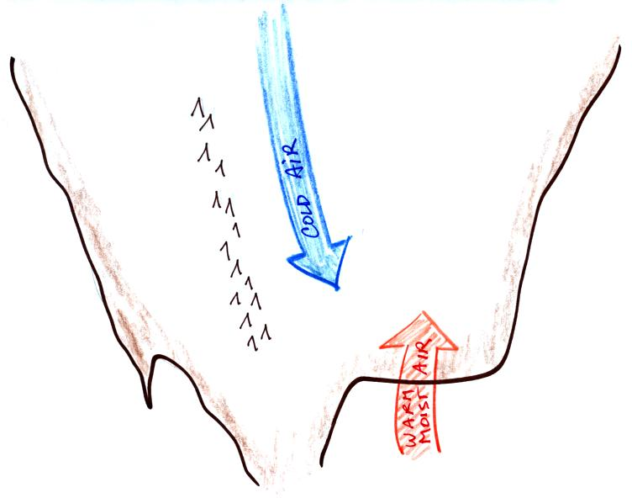 | 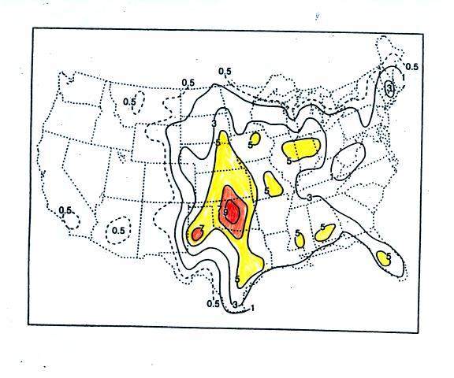
In the spring, cold dry air can move all the way from Canada and collide with warm moist air from the Gulf of Mexico to form strong cold fronts and thunderstorms.
Tornadoes have been observed in every state in the US, but tornadoes are most frequent in the central plains, a region referred to as "Tornado Alley" (highlighted in red, orange, and yellow above). The map at right above can be found on p. 161 in the photocopied ClassNotes.
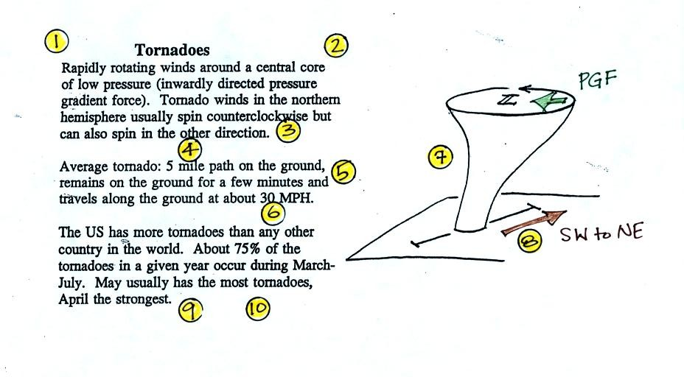
Here are some basic tornado characteristics (the figure above is found on p. 161 in the photocopied class notes).
1. About 2/3rds of tornadoes are F0 or F1 tornadoes (see below) and have spinning winds of about 100 MPH or less. Microburst winds can also reach 100 MPH. Microbursts are much more common in Tucson in the summer than tornadoes but can inflict the same level of damage (we'll look at tornado damage in class on Wednesday).
2. A very strong inwardly directed pressure gradient force is needed to keep winds spinning in a circular path. The PGF is much stronger than the Coriolis Force (CF) and the CF can be neglected. The pressure in the center core of a tornado can be 100 mb less than the pressure in the air outside the tornado. This is a very large pressure difference in a short distance.
3. Tornadoes can spin clockwise or counterclockwise, though counterclockwise rotation is more common.
4, 5, 6. Tornadoes usually last only a few minutes, leave a path on the ground that is a few miles long, and move at a few 10s of MPH. We will look at an exception below.
7, 8. Most tornadoes move from the SW toward the NE. This is because tornado-producing thunderstorms are often found just ahead of a cold front. Winds ahead of a cold front often blow from the SW. Most tornadoes have diameters of a few hundred yards but tornadoes with diameters over a mile have been observed.
9, 10. Tornadoes are most frequent in the Spring. The strongest tornadoes also occur at that time of year. Tornadoes are most common in the late afternoon when the atmosphere is most unstable.
The Fujita Scale is used to rate tornado strength and damage potential. It is very hard to actually measure the speed of the rotating winds in a tornado. Researchers usually survey the damage caused by the tornado to come up with a Fujita Scale rating. Here is a simplified, easy to remember, version of the Fujita Scale.
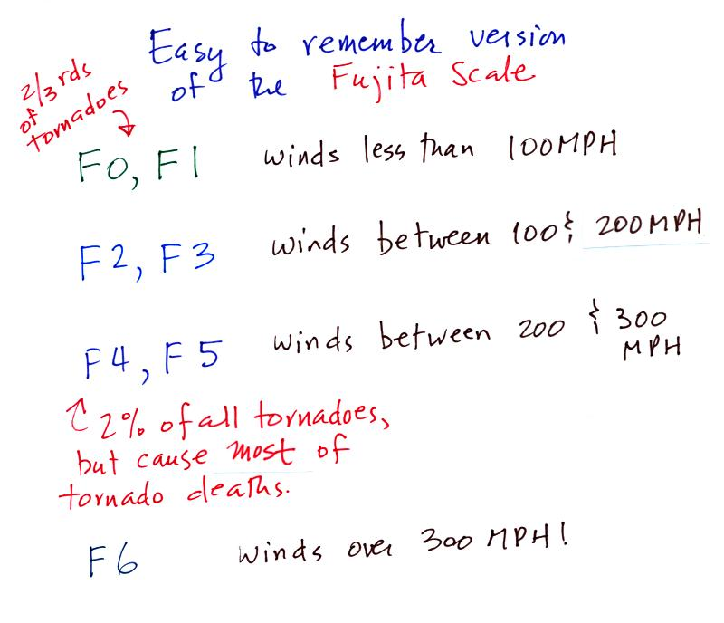

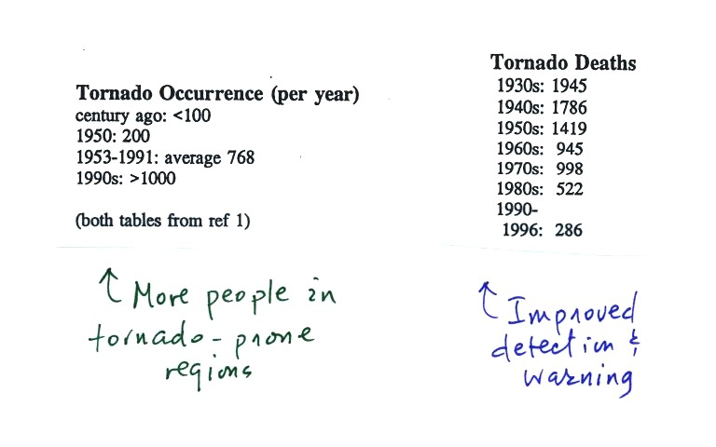
At the present time about 75 people are killed every year in the United States. Lightning and flash floods (floods are the most serious severe weather hazard) kill slightly more people. Hurricanes kill fewer people on average than tornadoes. Heat in the summer and cold in the winter kill many more people than floods, tornadoes, lightning, and hurricanes.

Most tornadoes last only a few minutes and leave a path a few miles long on the ground. There are of course exceptions. One is discussed below.
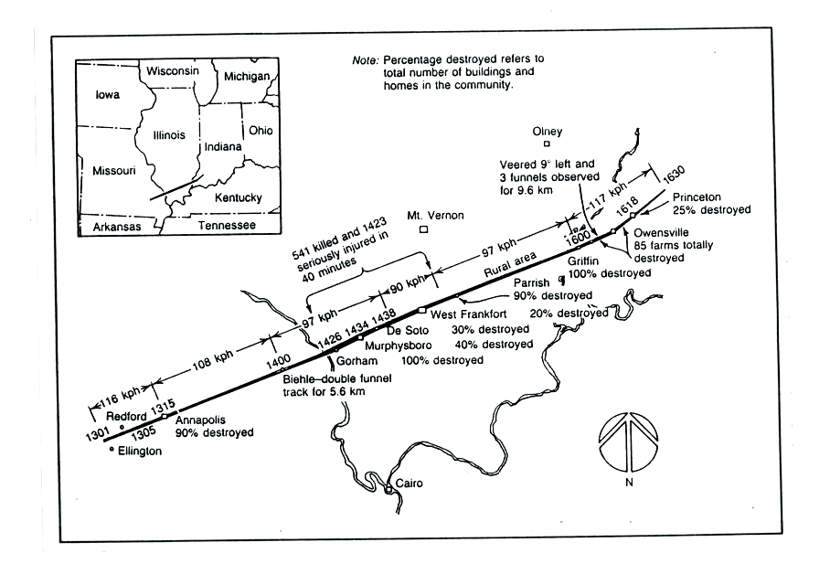
The path of the 1925 "Tri-State Tornado" is shown above. The tornado path (note the SW to NE orientation) was 219 miles long, the tornado last about 3.5 hours and killed 695 people. The tornado was traveling over 60 MPH over much of its path. It is the deadliest single tornado ever in the United States.
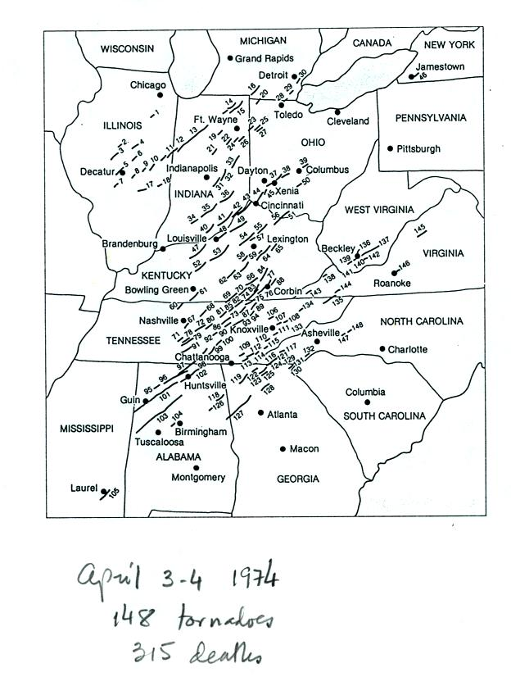 | 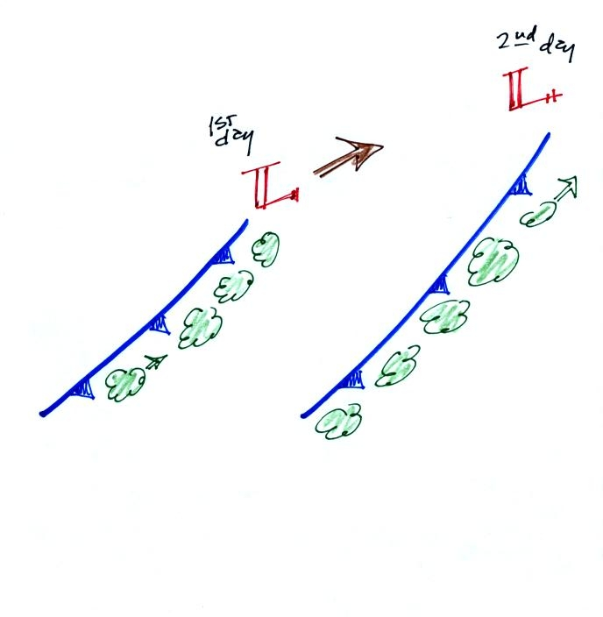
Tornadoes often occur in "outbreaks." The paths of 148 tornadoes during the April 3-4, 1974 "Jumbo Tornado Outbreak" are shown above. Note the first tornadoes were located in the upper left corner of the map. The tornadoes were produced by thunderstorms forming along a cold front. During this two day period the front moved from the NW part toward the SE part of the figure. Note that all the tornado paths have a SE toward NE orientation.

The figure below shows the steps in the formation, intensification, and weakening of a tornado. This is sometimes referred to as the tornado life cycle. Don't worry about learning the names of the various stages. The idea is for you to be able to recognize an unusually strong tornado if you ever see one in person or on video tape. You might also be able to tell from a tornadoes appearance whether it is near the beginning or end of its life cycle.
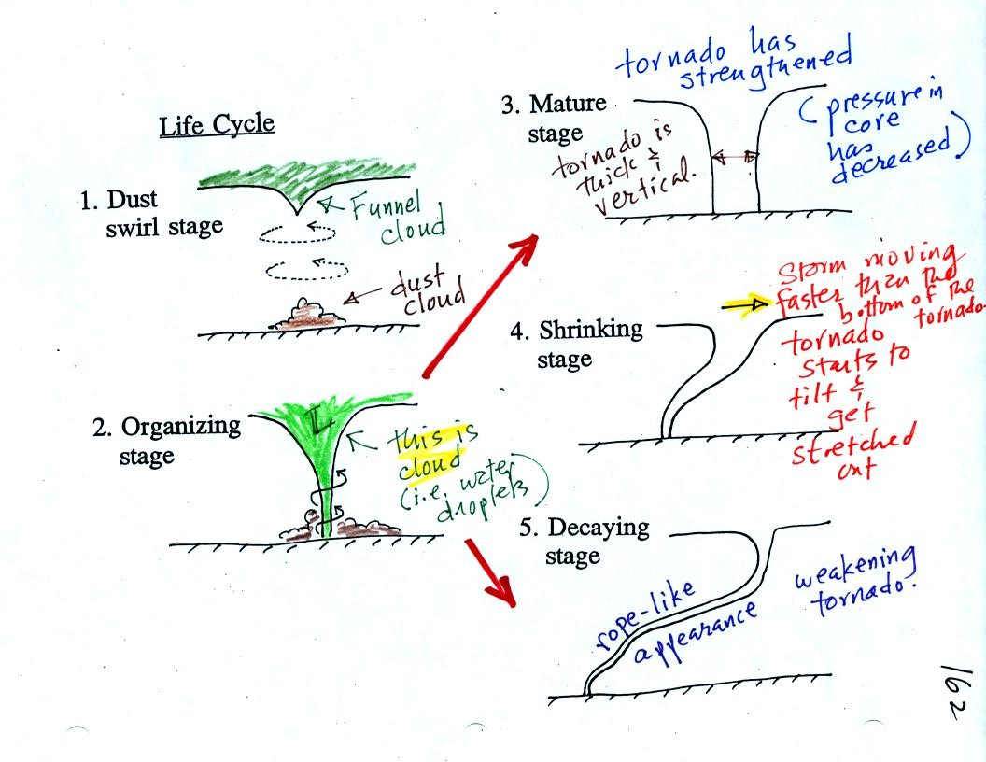
Tornadoes begin in and descend from a thunderstorm. You might see a funnel cloud dropping from the base of the thunderstorm. Spinning winds will probably be present between the cloud and ground before the tornado cloud becomes visible. The spinning winds can stir up dust at ground level. The spinning winds might also be strong enough at this point to produce some minor damage. We saw an example of this in a video tape of a tornado in Oklahoma.
In Stage 2, moist air moves horizontally toward the low pressure in the core of the tornado. This sideways moving air will expand and cool just as rising air does (see figure below). Once the air cools enough (to the dew point temperature) a cloud will form.
Tornadoes can go from Stage 2 to Stage 3 (this is what the strongest tornadoes do) or directly from stage 2 to stage 5. Note a strong tornado is usually vertical and thick as shown in Stage 3. "Wedge tornadoes" actually appear wider than they are tall.
The thunderstorm and the top of the tornado will move faster than the surface winds and the bottom of the tornado. This will tilt and stretch the tornado. The rope like appearance in Stage 5 is usually a sign of a weakening (though still a dangerous) tornado.
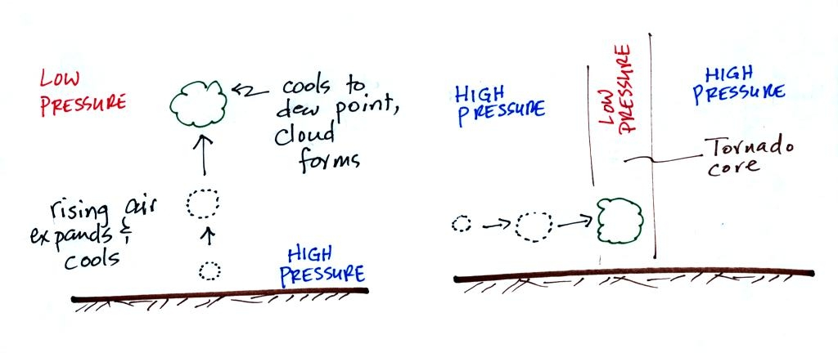
The tornado cloud forms when moist air moves into lower pressure in the core of the tornado. The air expands and cools to the dew point and a cloud forms. This is just like the cloud that forms when air rises.

At this point we watched a short video segment that illustrated well the first 3 steps in the formation of a tornado (dust swirl stage up to mature stage). The tornado was photographed near Luverne Oklahoma in May 1991. It was eventually rated an F3 tornado.
This was followed by another short video with images of several different tornadoes was shown. Descriptions of the tornadoes are given in the table below (the numbers in the left most column were used on the video to identify each tornado)

54a | F3 | Grand Island, NE | Mar. 13, 1990 | tornado cloud is pretty thick and vertical
61f | F3 | McConnell AFB KS | Apr. 26, 1991 | this is about as close to a tornado as you're ever likely to get. Try to judge the diameter of the tornado cloud. What direction are the tornado winds spinning?
52 | F5 | Hesston KS | Mar. 13, 1990 | Watch closely, you may see a tree or two uprooted by the tornado winds
51 | F3 | North Platte NE | Jun. 25, 1989 | Trees uprooted and buildings lifted by the tornado winds
65 | F1 | Brainard MN | Jul. 5, 1991 | It's a good thing this was only an F1 tornado
57 | F2 | Darlington IN | Jun. 1, 1990 | Tornado cloud without much dust
62b | F2 | Kansas Turnpike | Apr. 26, 1991 | It's sometimes hard to run away from a tornado. Watch closely you'll see a van blown off the road and rolled by the tornado. The driver of the van was killed!
47 | F2 | Minneapolis MN | Jul. 18, 1986 | Tornado cloud appears and disappears.

