Friday, Feb. 6, 2009
Music today was "Try" from a group named ALO.
The Practice Quiz has been graded and was returned in class today. The average was 60% which is pretty typical for a practice quiz. You'll find answers to the questions here. Quiz #1 will cover material on the practice quiz and new material that we cover in the next week and a half or so.
The Experiment #1 reports are due next Monday. Please return your materials then if you haven't done so, the graduated cylinders are needed for Experiment #2.

The main goal of today's class is to understand why warm air rises and cold air sinks.
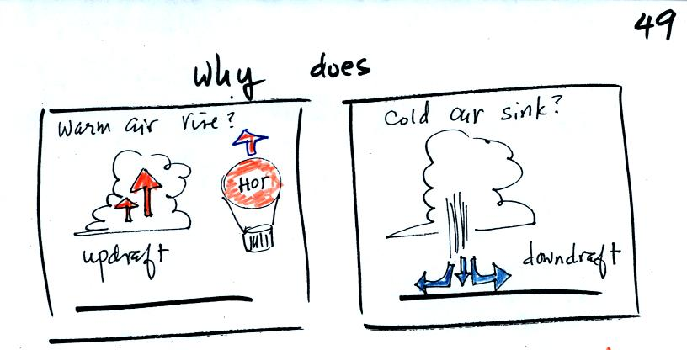
Hot air balloons rise (they also sink), so does the relatively warm air in a thunderstorm (its warmer than the air around it). Conversely cold air sinks. The surface winds caused by a thunderstorm downdraft (as shown above) can reach speeds of 100 MPH and are a serious weather hazard.
A full understanding of this is a 3-step process:
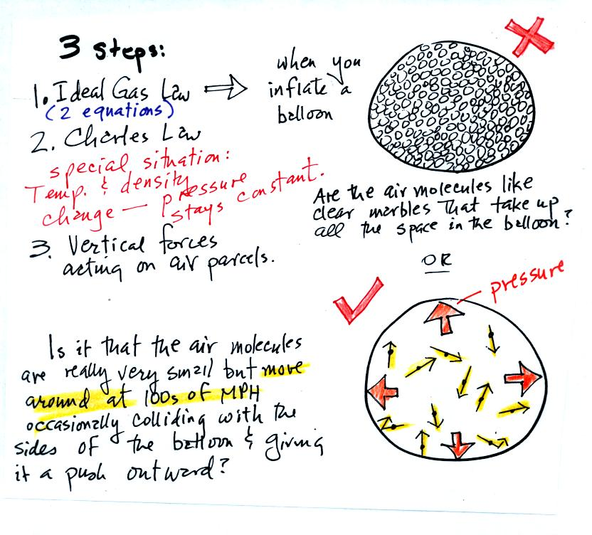
The figure above is the bottom part of p. 49 in the photocopied ClassNotes. We will first learn about the ideal gas law. That is an equation that tells you how properties of the air inside a balloon work to determine the air's pressure. Then we will look at Charles' Law, a special situation involving the ideal gas law (air temperature and density work together in a way that keeps the pressure inside a balloon constant). Then we'll learn about the vertical forces that act on air (an upward and a downward force)
The figure above makes an important point: the air molecules in a balloon "filled with air" really take up very little space. A balloon filled with air is really mostly empty space. It is the collisions of the air molecules with the inside walls of the balloon that keep it inflated.
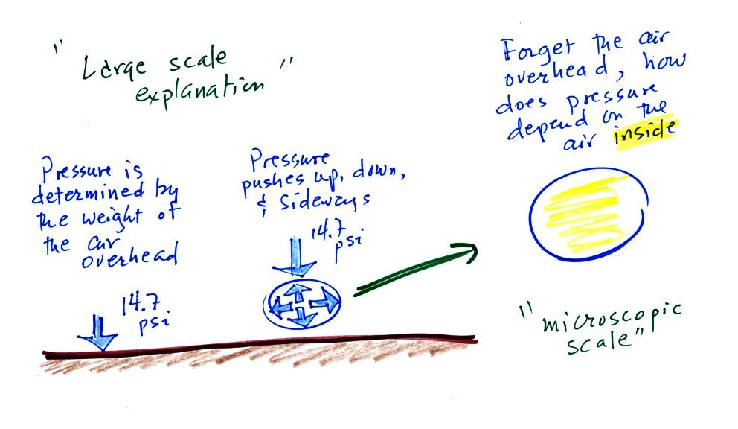
Up to this point in the semester we have been thinking of pressure as being determined by the weight of the air overhead. Air pressure pushes down against the ground at sea level with 14.7 pounds of force per square inch. If you imagine the weight of the atmosphere pushing down on a balloon sitting on the ground you realize that the air in the balloon pushes back with the same force. Air everywhere in the atmosphere pushes upwards, downwards, and sideways.
The ideal gas law equation is another way of thinking about air pressure. We ignore the atmosphere and concentrate on just the air inside the balloon. We are going to "derive" an equation. Pressure (P) will be on the left hand side. Properties of the air inside the balloon will be found on the right side of the equation.
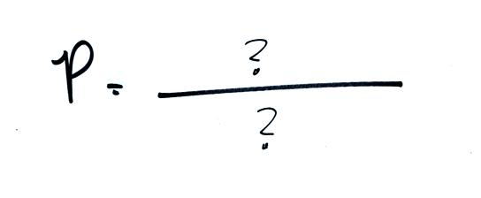

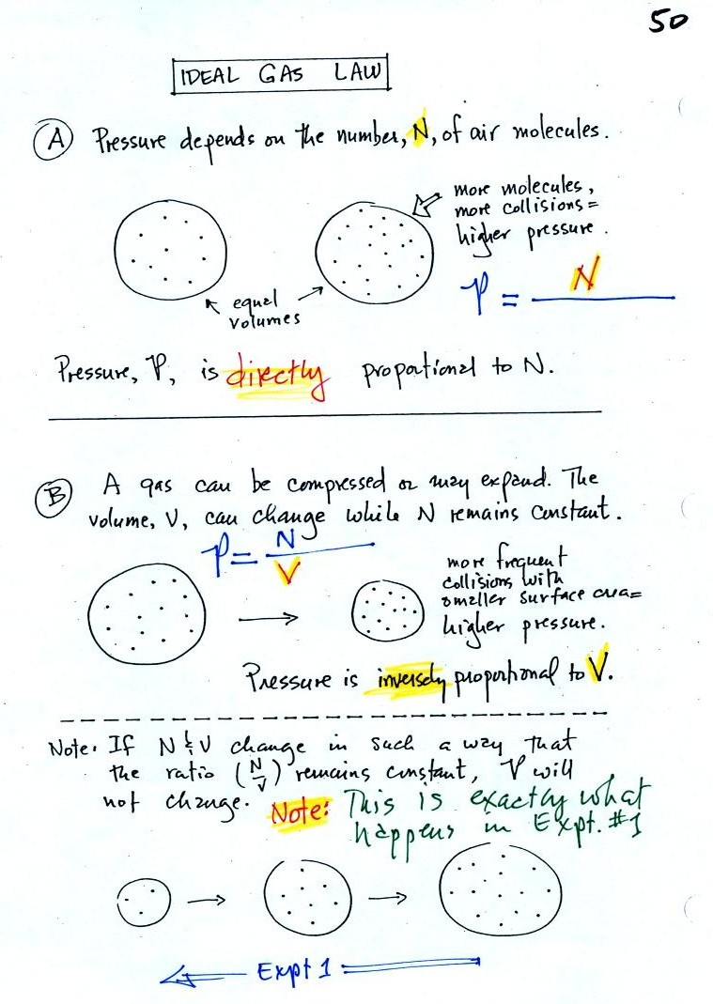
In A
the pressure produced by the air molecules inside a balloon will first depend on how many air molecules are there. If there weren't any air molecules at all there wouldn't be any pressure. As you add more and more add to something like a bicycle tire, the pressure increases. Pressure is directly proportional to N - an increase in N causes an increase in P. If N doubles, P also doubles (as long as the other variables in the equation don't change).
In B
air pressure inside a balloon also depends on the size of the balloon. Pressure is inversely proportional to volume, V . If V were to double, P would drop to 1/2 its original value.
Note
it is possible to keep pressure constant by changing N and V together in just the right kind of way. This is what happens in Experiment #1 that some of you are working on. Oxygen in a graduated cylinder reacts with steel wool to form rust. Oxygen is removed from the air sample which is a decrease in N. As oxygen is removed, water rises up into the cylinder decreasing the air sample volume. N and V both decrease in the same relative amounts and the air sample pressure remains constant. If you were to remove 20% of the air molecules, V would decrease to 20% of its original value and pressure would stay constant.
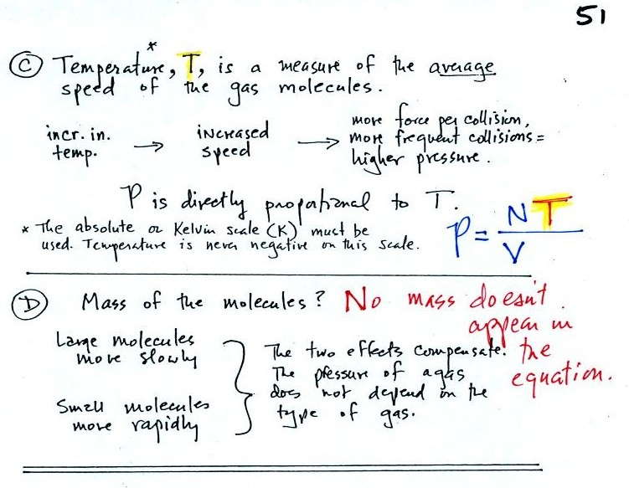
Increasing the temperature of the gas in a balloon will cause the gas molecules to move more quickly. They'll collide with the walls of the balloon more frequently and rebound with greater force. Both will increase the pressure. You shouldn't throw a can of spray paint into a fire because the temperature will cause the pressure inside the can to increase and the can could explode. We'll demonstrate the effect of temperature on pressure in class on Friday.
Surprisingly the pressure does not depend on the mass of the molecules. Pressure doesn't depend on the composition of the gas. Gas molecules with a lot of mass will move slowly, the less massive molecules will move more quickly. They both will collide with the walls of the container with the same force.
The figure below (which replaces the bottom of p. 51 in the photocopied ClassNotes) shows two forms of the ideal gas law. The top equation is the one we just derived and the bottom is a second slightly different version. You can ignore the constants k and R if you are just trying to understand how a change in one of the variables would affect the pressure. You only need the constants when you are doing a calculation involving numbers.
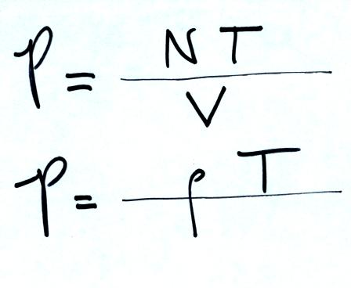

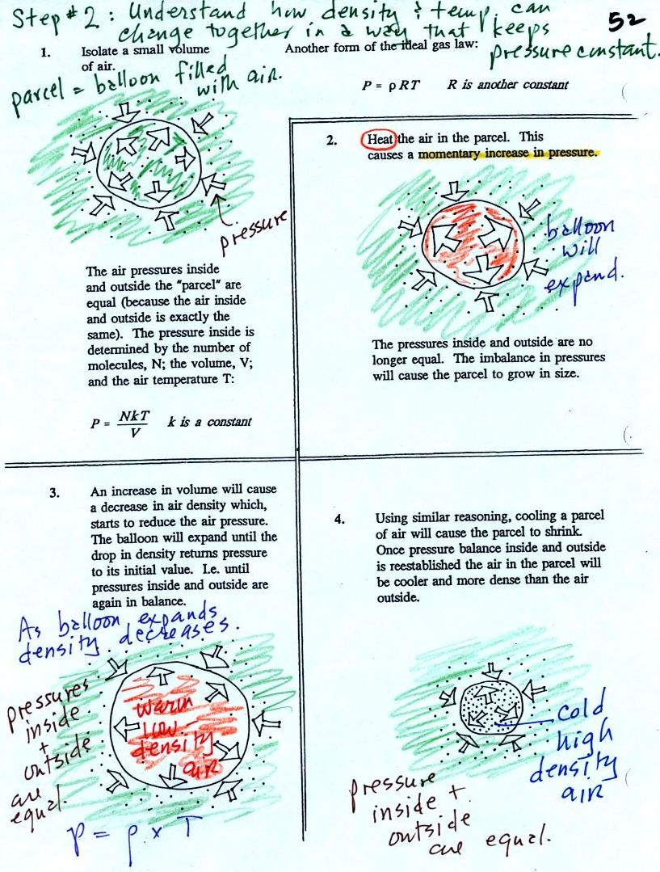
Read through the explanation on p. 52 in the photocopied Classnotes.
These two associations:
(i) warm air = low density air
(ii) cold air = high density air
are important and will come up a lot during the remainder of the semester.
Click here if you would like a little more detailed, more step-by-step, explanation of Charles Law. Otherwise proceed on to the Charles' Law demonstration that we did in class.

Charles Law can be demonstrated by dipping a balloon in liquid nitrogen. You'll find an explanation on the top of p. 54 in the photocopied ClassNotes.
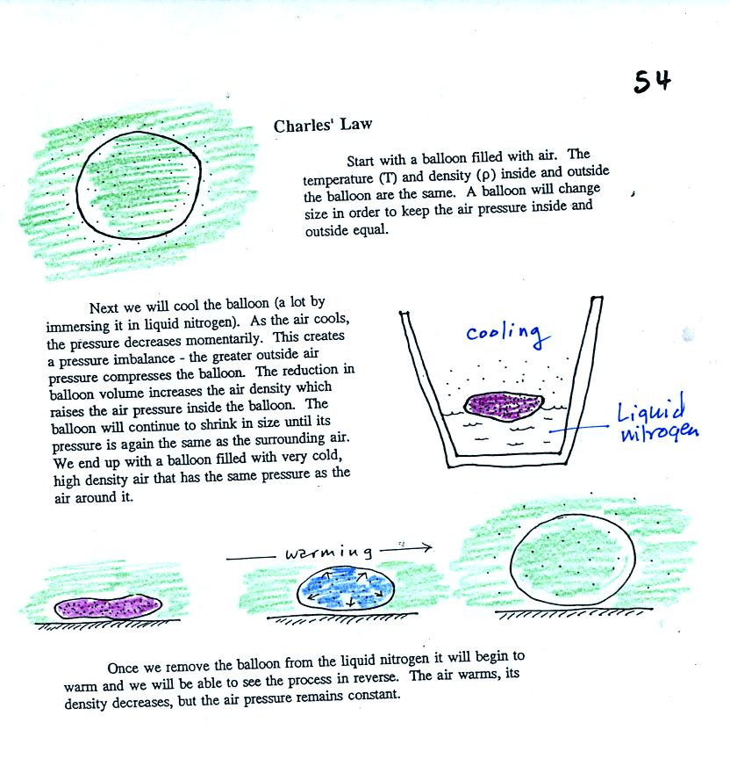
The balloon had shrunk down to practically no volume when pulled from the liquid nitrogen. It was filled with cold high density air. As the balloon warmed the balloon expanded and the density of the air inside the balloon decreased. The volume and temperature kept changing in a way that kept pressure constant.
Here's a summary (not shown in class)
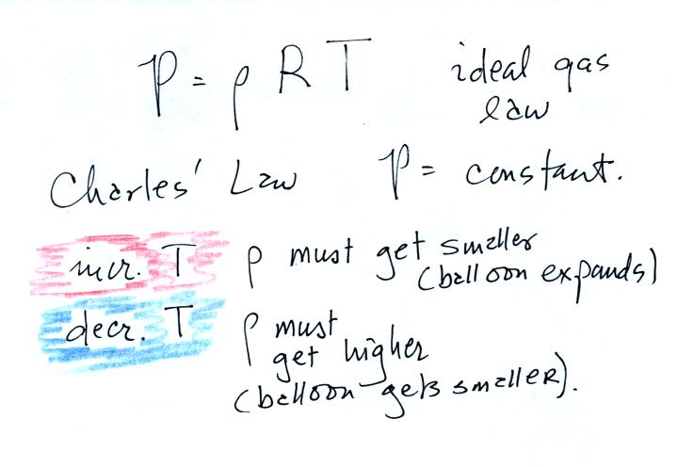

Now finally on to step #3. Found on p. 53 in the photocopied ClassNotes.

Basically what it comes down to is this - there are two forces acting on a parcel (balloon) of air:
Gravity pulls downward. The strength of the gravity force depends on the mass of the air inside the balloon.
There is an upward pointing pressure difference force. This is caused by the air surrounding the balloon.
When the air inside a parcel is exactly the same as the air outside, the two forces have equal strengths and cancel out. The parcel is neturally bouyant and doesn't rise or sink.
If you replace the air inside the balloon with warm low density air, it won't weigh as much. The gravity force is weaker, the upward pressure difference force wins and the balloon will rise.
Conversely if the air inside is cold high density air, it weighs more. Gravity is stronger than the upward pressure difference force and the balloon sinks.

To demonstrate free convection we modified the Charles Law demonstration. We used balloons filled with hydrogen instead of air (see bottom of p. 54 in the photocopied Class Notes). Hydrogen is less dense than air even when the hydrogen has the same temperature as the surrounding air. A hydrogen-filled balloon doesn't need to warmed up in order to rise.
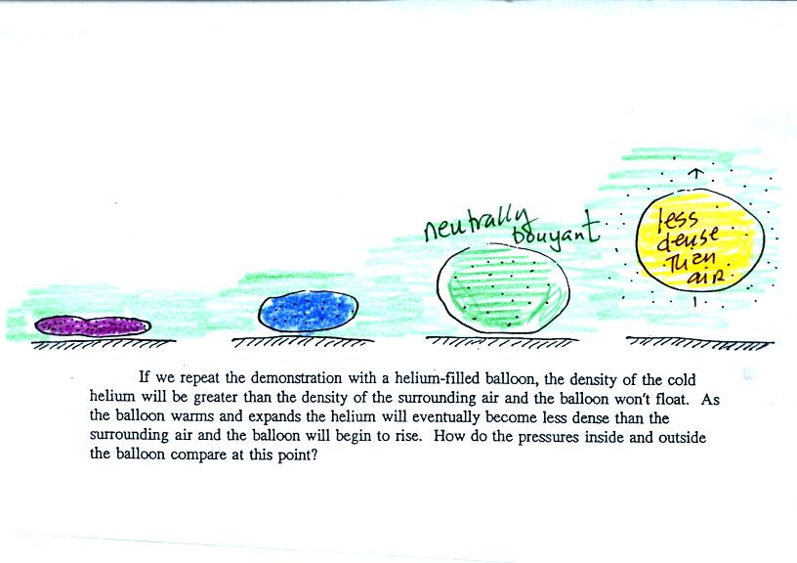
We dunked the helium-filled balloon in some liquid nitrogen to cool it and to cause the density of the helium to increase. When removed from the liquid nitrogen the balloon didn't rise, the gas inside was denser than the surrounding air (the purple and blue balloons in the figure above). As the balloon warms and expands its density decreases. The balloon at some point has the same density as the air around it (green above) and is neutrally bouyant. Eventually the balloon becomes less dense that the surrounding air (yellow) and floats up to the ceiling.
Here's an example of where something like this happens in the atmosphere.
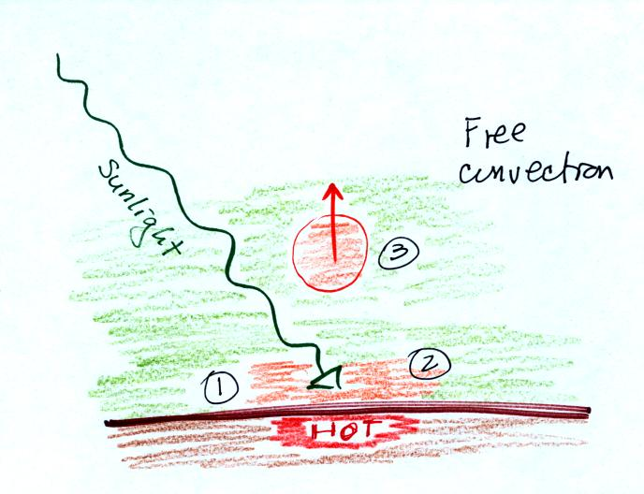
At (1) sunlight reaching the ground is absorbed and warms the ground. This in turns warms air in contact with the ground (2). Once this air becomes warm and its density is low enough, small blobs of air separate from the air layer at the ground and begin to rise (3). This is called free convection; many of our summer thunderstorms start this way.

