Friday Feb. 20, 2009
A tough crowd to please this afternoon, music-wise. I think we finally settled on Buckwheat Zydeco.
Quiz #1 is graded and was returned in class. The class average was pretty high: 79%. Check to be sure your quiz was graded correctly and that the points were added up correctly. Note you can only earn up to 10 pts on the extra credit questions (I usually put that in parentheses but forgot this time).

During the next few weeks we will be concerned with energy, temperature, heat, energy transport, and energy balance between the earth, atmosphere, and space.
It is easy to lose sight of the main concepts because there are so many details. The following (found on pps 43&44 in the photocopied Class Notes) is meant to introduce some of what we will be covering in class.
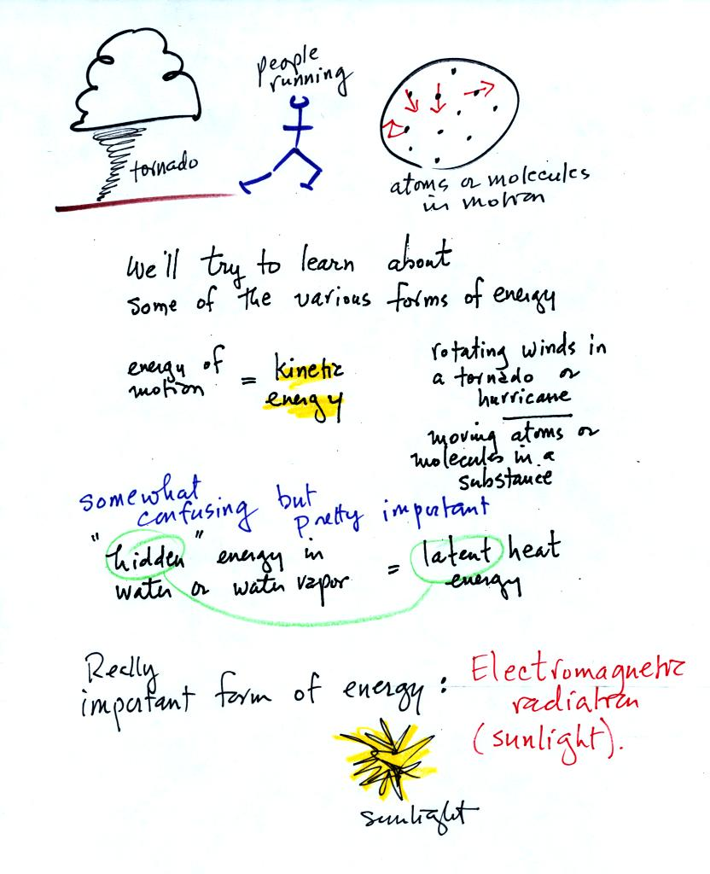
We will learn the names of several different types or forms of energy. Kinetic energy is energy of motion. Some examples are mentioned and sketched above. It is a relatively easy to visualize and understand form of energy.
Latent heat energy is perhaps the most underappreciated and most confusing type of energy. The word latent refers to energy that is hidden in water and water vapor. The hidden energy emerges when water vapor condenses or water freezes.
Radiant energy is a very important form of energy that was for some reason left off the original list. Sunlight is an example of radiant energy that we can see and feel (you feel warm when you stand in sunlight). There are many types of radiant energy that are invisible.
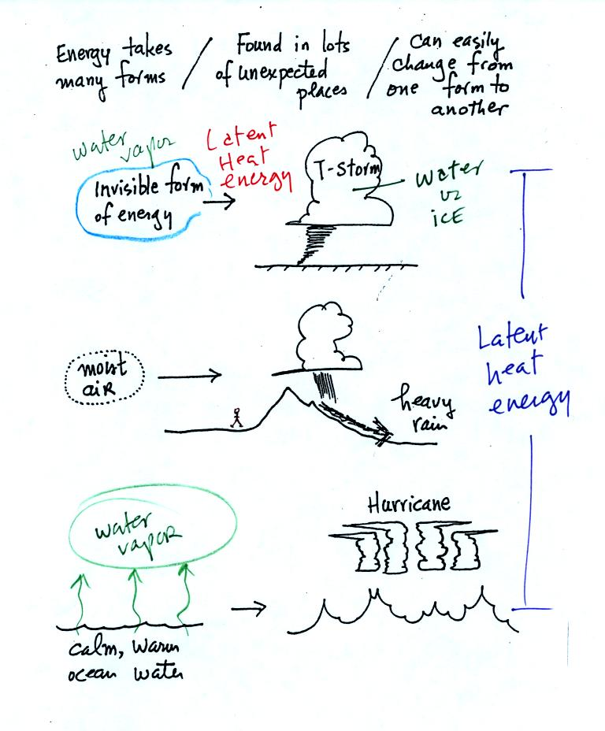
Water vapor is a particularly important form of invisible energy. When water vapor condenses to produce the water droplets (or ice crystals) in a cloud, an enormous amount of latent heat energy is released into the atmosphere.
It is hard to visualize or appreciate the amount of energy released into the atmosphere during condensation. You can imagine the work that you would do carrying a gallon of water (8 pounds) from Tucson to the top of Mt. Lemmon. To accomplish the same thing Mother Nature must first evaporate the water and (if my calculations are correct) that requires about 100 times the energy that you would use to carry the 8 pounds of water to the summit of Mt. Lemmon. And Mother Nature transports a lot more than just a single gallon.
Four energy transport processes are listed below.

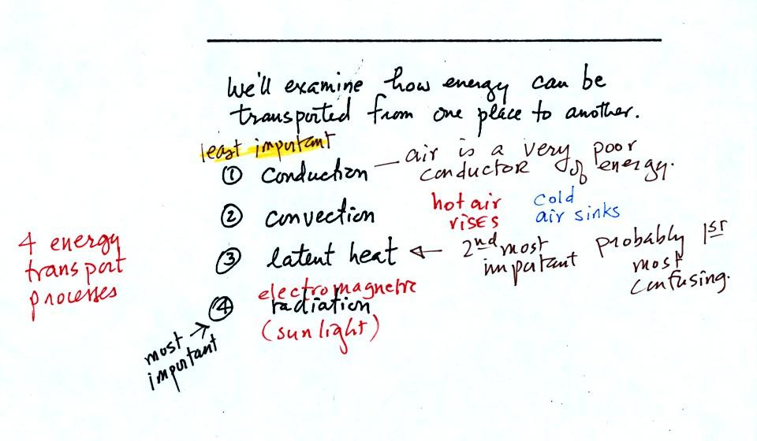
By far the most important process is electromagnetic radiation (light is a common form of electromagnetic radiation). This is the only process that can transport energy through empty space. Electromagnetic radiation travels both to the earth (from the sun) and away from the earth into space. Electromagnetic radiation is also responsible for about 80% of the energy transported between the ground and atmosphere.
You might be surprised to learn that latent heat is the second most important transport process.
Rising parcels of warm air and sinking parcels of cold air are examples of free convection. Because of convection you feel colder or a cold windy day than on a cold calm day. Ocean currents are also an example of convection. Ocean currents transport energy from the warm tropics to colder polar regions.
Note that convection is a 3rd way of causing rising air motions in the atmosphere (convergence into centers of low pressure, and fronts were the other two ways).
Conduction is the least important energy transport at least in the atmosphere. Air is such a poor conductor of energy that it is generally considered to be an insulator.

Water vapor is a particularly important form of invisible energy. When water vapor condenses to produce the water droplets (or ice crystals) in a cloud, an enormous amount of latent heat energy is released into the atmosphere.
It is hard to visualize or appreciate the amount of energy released into the atmosphere during condensation. You can imagine the work that you would do carrying a gallon of water (8 pounds) from Tucson to the top of Mt. Lemmon. To accomplish the same thing Mother Nature must first evaporate the water and (if my calculations are correct) that requires about 100 times the energy that you would use to carry the 8 pounds of water to the summit of Mt. Lemmon. And Mother Nature transports a lot more than just a single gallon.
The next picture shows energy being transported from the sun to the earth in the form of electromagnetic radiation.
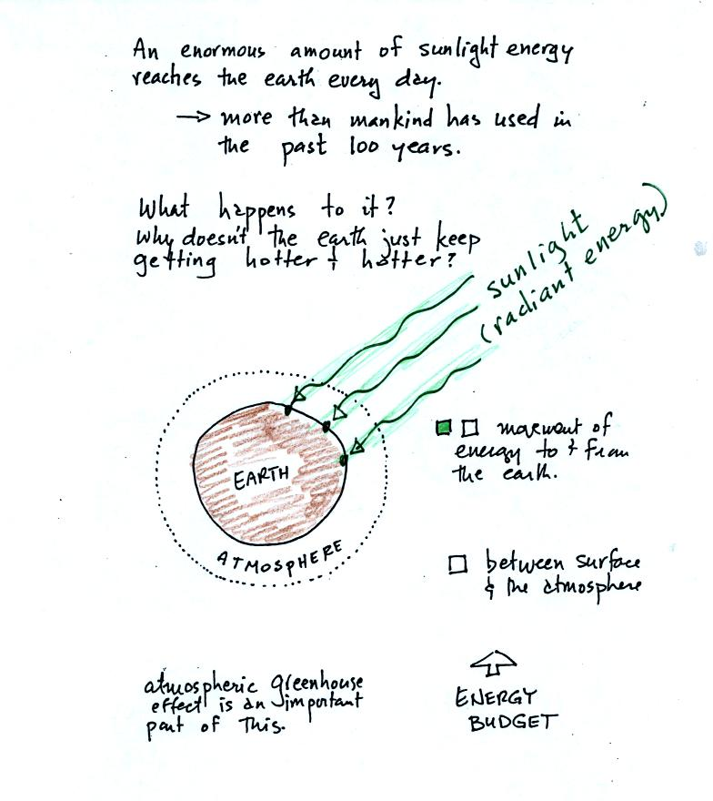
We are aware of this energy because we can see it (sunlight also contains invisible forms of light) and feel it. With all of this energy arriving at and being absorbed by the earth, what keeps the earth from getting hotter and hotter? The answer is that the earth also sends energy back into space (the orange and pink arrows in the figure below)
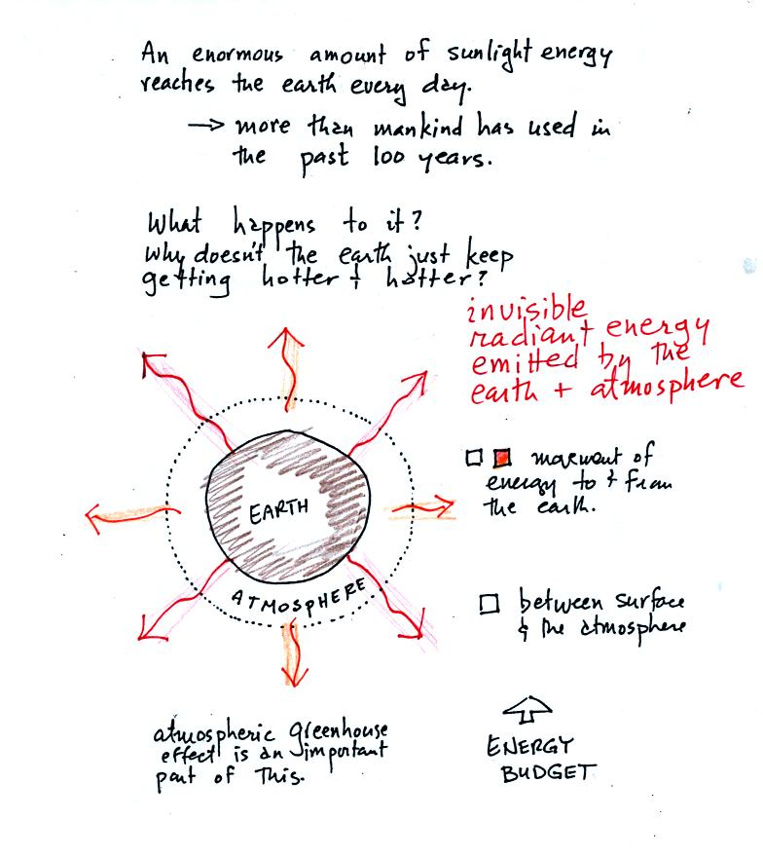
This infrared light is an invisible form of energy (it is weak enough that we don't usually feel it either). A balance between incoming and outgoing energy is achieved and the earth's annual average temperature remains constant.
We will also look closely at energy transport between the earth's surface and the atmosphere. This is where latent heat energy transport and convection and conduction operate (they can't outside the atmosphere into outer space).
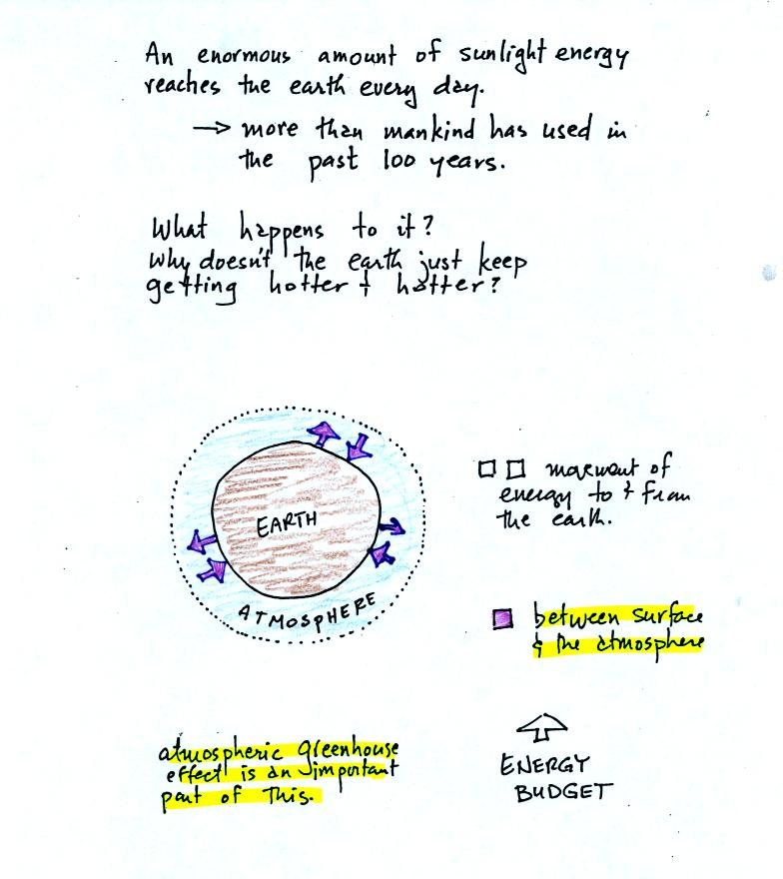
That is also where the atmospheric greenhouse operates. That will be a important goal - to better understand how the atmospheric greenhouse effect works.
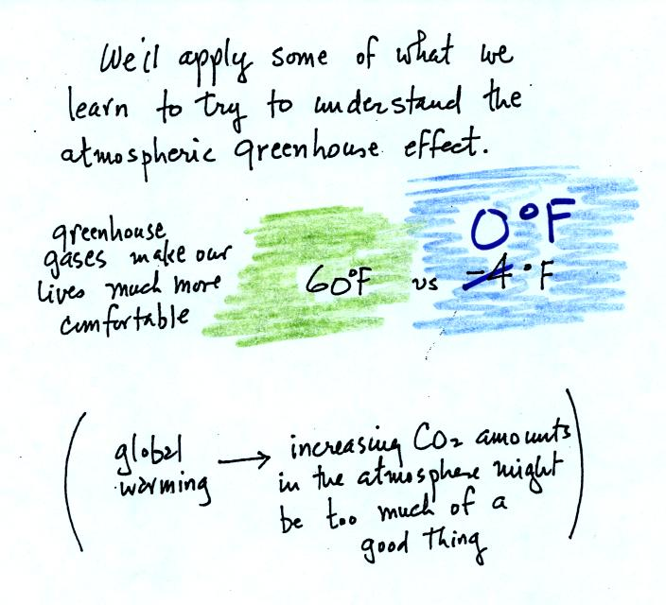
Remember that without the greenhouse effect, the global annual average surface temperature on the earth would be about 0º F rather than 60º F.

When you add energy to an object, the object will usually warm up (conversely when you take energy from an object the object will cool). It is relatively easy to come up with an equation that allows you to figure out what the temperature change will be.
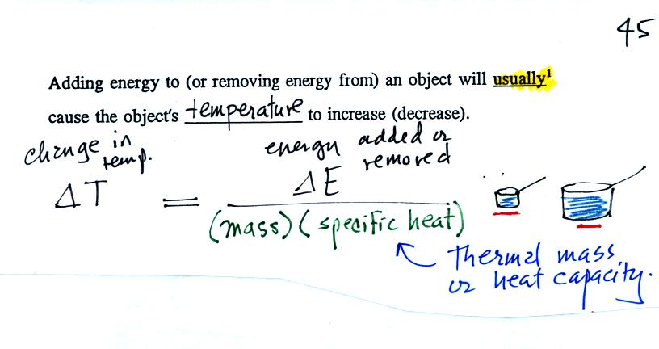
The temperature change will first depend on how much energy was added. This is a direct proportionality, so delta E is in the numerator of the equation.
When you add equal amounts of energy to large and small pans of water, the small pan will heat up more quickly. The temperature change, delta T, will depend on the mass. A small mass will mean a large delta T, so mass should go in the denominator of the equation.
Different materials react differently when energy is added to them. A material with a large specific heat will warm more slowly than a material with a small specific heat. Specific heat has the same kind of effect on delta T as mass. Specific heat is sometimes called "thermal mass" or "thermal capacity."
Here's an important example that will show the effect of specific heat (middle of p. 45)
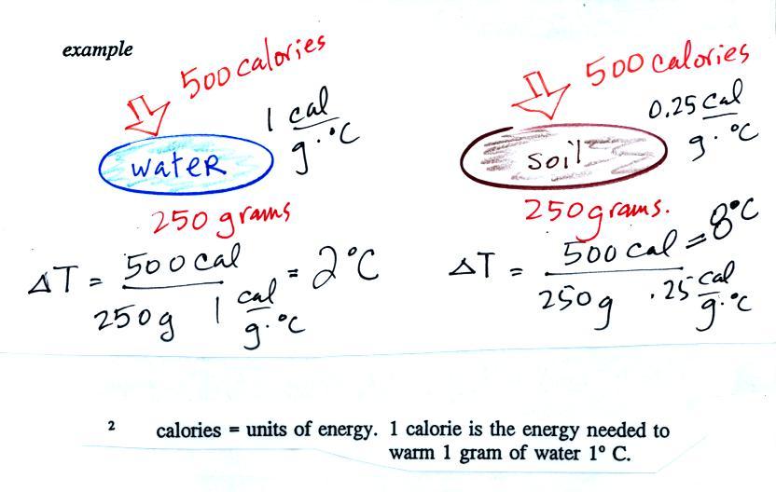
Equal amounts of energy (500 calories, note that calories are units of energy) are added to equal masses (250 grams) of water and soil. We use water and soil in the example because most of the earth's surface is either ocean or land. Water has a higher specific heat than soil, it only warms up 2º C. The soil has a lower specific heat and warms up 8º C, 4 times more than the water.
These different rates of warming of water and soil have important effects on regional climate. (the following figure was not shown in class)
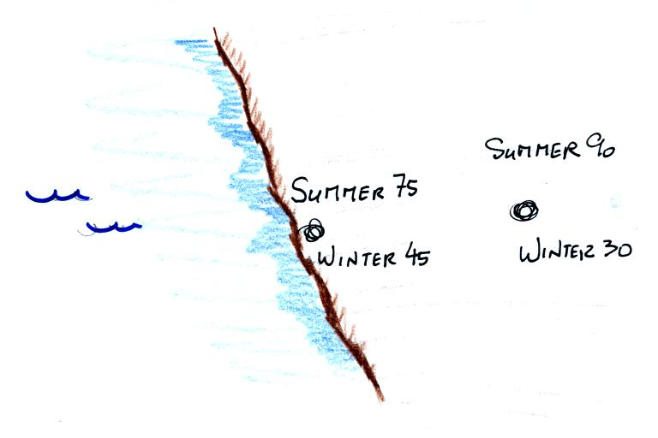
Oceans moderate the climate. Cities near a large body of water won't warm as much in the summer and won't cool as much during the winter compared to a city that is surrounded by land.
The city above on the coast has a 30º F annual range of temperature (range is the difference between the summer and winter temperatures). The city further inland (assumed to be at the same latitude and altitude) has an annual range of 60º F. Note that both cities have the same 60º F annual mean temperature.

Adding energy to an object will usually cause it to warm. But there is another possibility (bottom p. 45), the object could change phase (change from solid to liquid or gas). Adding energy to ice might cause the ice to melt. Adding energy to water could cause it to evaporate.
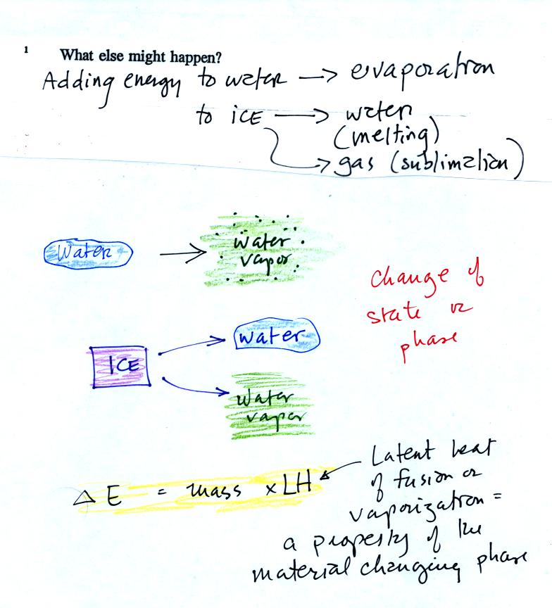
The equation at the bottom of the figure above allows you to calculate how much energy is required to melt ice or evaporate water or sublimate dry ice. You multiply the mass by the latent heat, a variable that depends on the particular material that is changing phase.

Next we learned a little bit about the Piccard family.
Auguste Piccard (together with Paul Kipfer, see p. 32 in the photocopied ClassNotes) was the lead member of a two-man team that made the first trip into the stratosphere in a balloon. They did that on May 27, 1931. A short video was shown in class describing their trip.
Jacques Piccard (Auguste's son) was part of a two-man team that traveled to the deepest point in the ocean (35,800 feet) in a bathyscaph. You'll see a short segment from a early test of the bathyscaph where Auguste and Jacques descend to 10,000 feet.
Finally Bertrand Piccard (Jacques' son, Auguste's grandson) was part of the two man team that first circled the globe nonstop in a balloon. That occurred fairly recently, March 20, 1999, I believe. I also plan to show you some of that trip also.

