Monday Feb. 23, 2009
Music today was The Ballad of Cable Hogue from Calexico. Calexico is a local group and appear fairly frequently at the Rialto theater in Tucson. They are just finishing up a European tour and will be appearing at Carnegie Hall on Mar. 11. On the DVD shown in class they were appearing together with Mariachi Luz de Luna (also from Tucson) and Francoiz Breut at the Barbican Theater in London.
The Experiment #2 reports are due Monday next week. Try to return your materials this week so that you can pick up the Supplementary Information sheet. The Experiment #3 materials should be distributed Wednesday or Friday next week.
Tomorow is Mardi Gras. Mardi Gras is the inspiration for this week's picture which can be viewed by clicking here.

Now back to business. Here's a little review of some of what we covered last Friday.
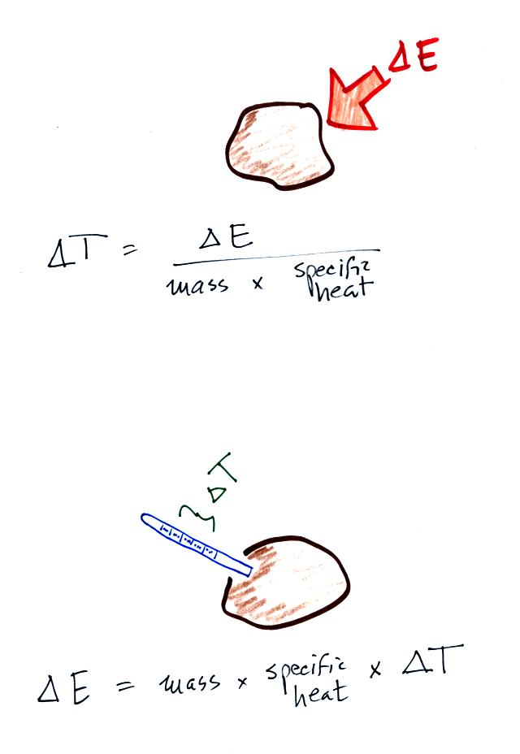
If you add energy to or remove energy from an object, the object will usually change temperature. You can calculate the temperature change if you know the object's mass and its specific heat.
We will be using the equation in a slightly different way in class today. We will measure the temperature change and use that to determine the amount of energy lost by an object.
Another thing we learned was that water has relatively high specific heat (4 or 5 times higher than soil for example). This has some important consequences.
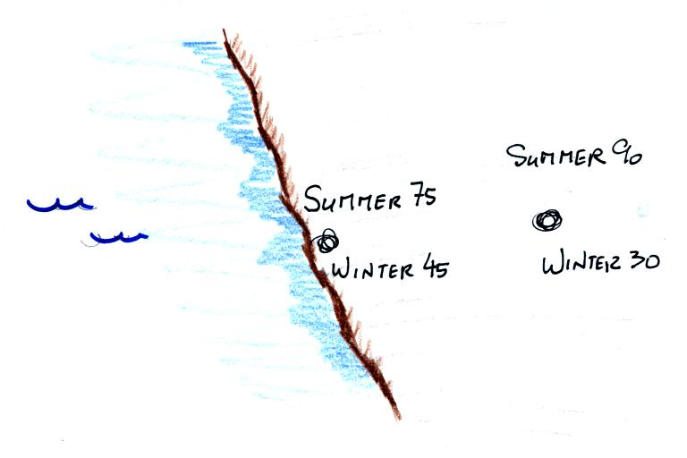
A city on a coast (especially the west coast) will have a more moderate climate than a city located inland (everything else being the same). It won't get as hot in the summer and won't get as cold in the winter. The annual range of temperature will be smaller. Water's high specific heat means it is hard to heat the water in the summer and hard to cool the water in the winter.

When you add energy to an object and the object warms, what exactly is happening inside the object?
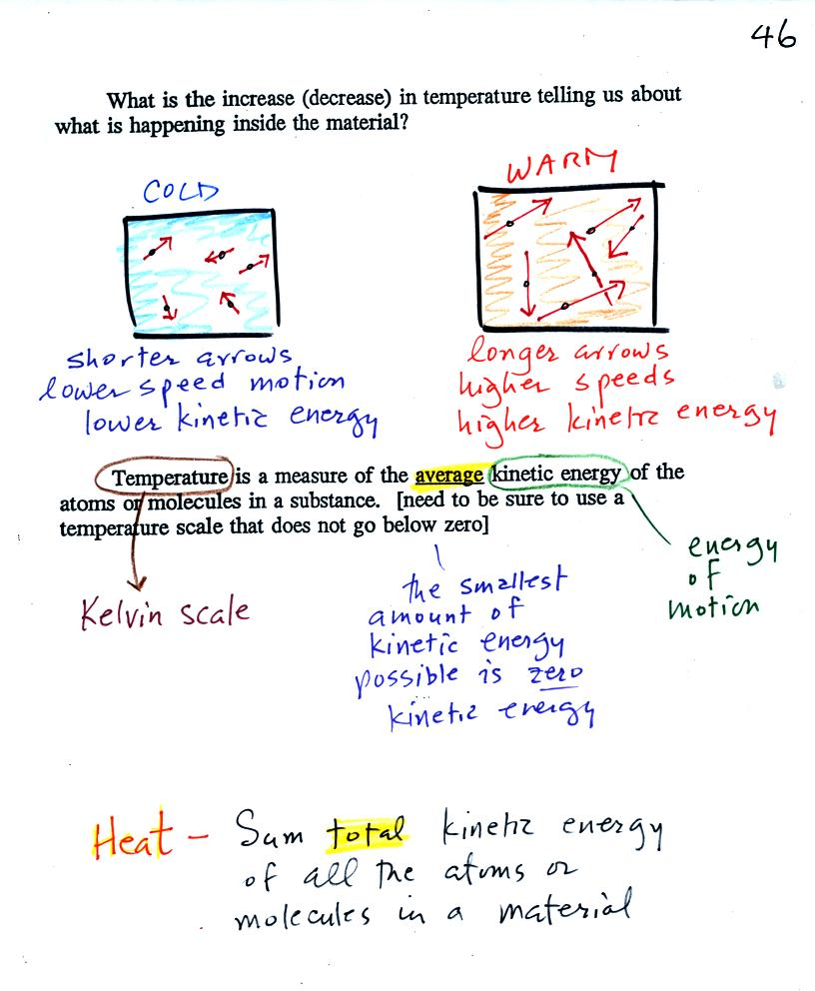
The figure above is on p. 46 in the photocopied Class Notes. Temperature provides a measure of the average kinetic of the atoms or molecules in a material. The atoms or molecules in a cold material will be moving more slowly than the atoms or molecules in a warmer object.
You need to be careful what temperature scale you use when using temperature as a measure of average kinetic energy. You must use the Kelvin temperature scale because it does not go below zero (0 K is known as absolute zero). The smallest kinetic energy you can have is zero kinetic energy. There is no such thing as negative kinetic energy.
You can think of heat as being the total kinetic energy of all the molecules or atoms in a material. The next figure might make the distinction between temperature (average kinetic energy) and heat (total kinetic energy) clearer.
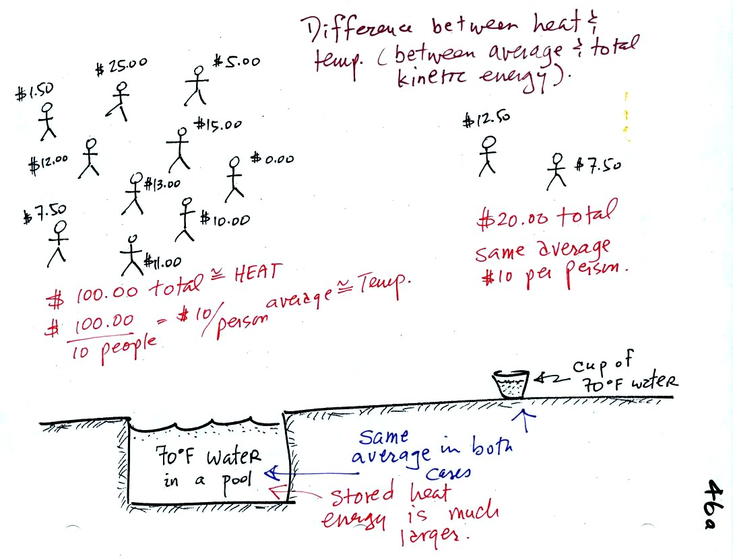
A cup of water and a pool of water both have the same temperature. The average kinetic energy of the water molecules in the pool and in the cup are the same. There are a lot more molecules in the pool than in the cup. So if you add together all the kinetic energies of all the molecules in the pool you are going to get a much bigger number than if you sum the kinetic energies of the molecules in the cup. There is a lot more stored energy in the pool than in the cup. It would be a lot harder to cool (or warm) all the water in the pool than it would be the cup.
In the same way the two groups of people shown have the same average amount of money per person. The $100 held by the larger group at the left is greater than the $20 total possessed by the smaller group of people on the right.

Speaking of temperature scales.
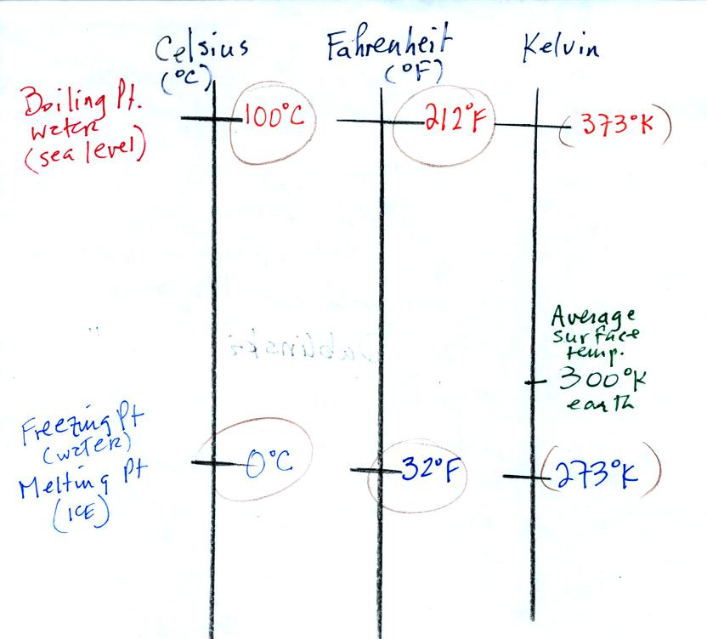
You should remember the temperatures of the boiling point and freezing point of water on the Fahrenheit, Celsius, and Kelvin scales. 300 K is a good easy-to-remember value for the global annual average surface temperature of the earth.
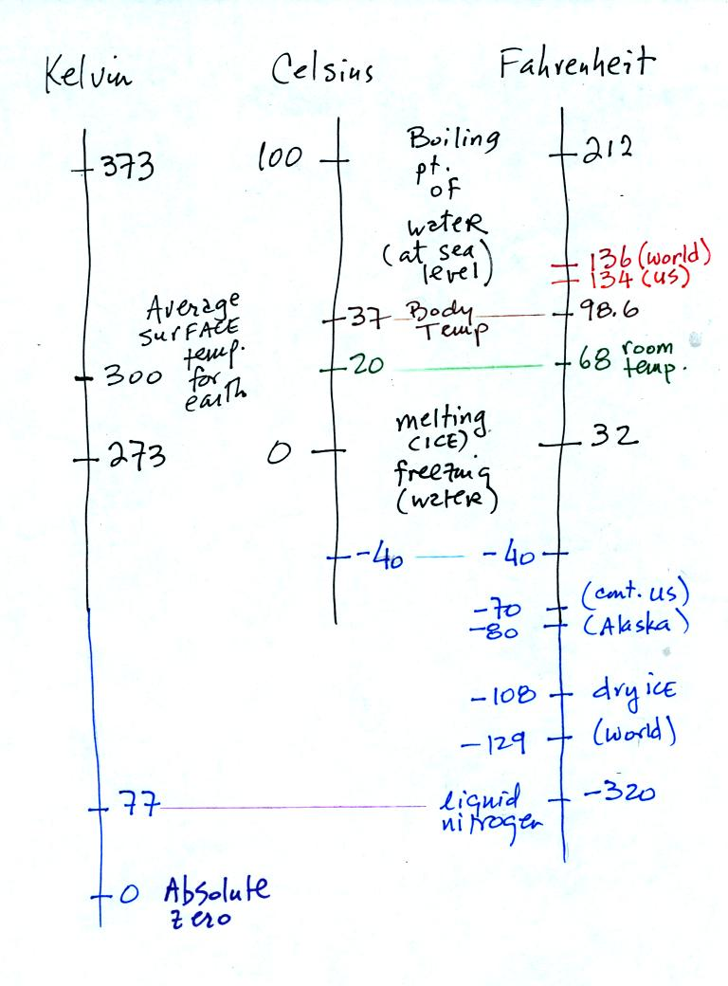
You certainly don't need to try to remember all these numbers. The world high temperature record was set in Libya, the US record in Death Valley. The continental US cold temperature record of -70 F was set in Montana and the -80 F value in Alaska. The world record -129 F was measured at Vostok station in Antarctica. This unusually cold reading was the result of three factors: high latitude, high altitude, and location in the middle of land rather than being near or surrounded by ocean. Liquid nitrogen is cold but it is still quite a bit warmer than absolute zero.

At this point a student from the class was brave enough to volunteer to do an experiment.
The object of the experiment was to measure the latent heat of vaporization of liquid nitrogen. That just means measuring the amount of energy needed to evaporate a gram of liquid nitrogen. The students that are doing Experiment #2 are measuring the latent heat of fusion of ice, the energy needed to melt one gram of ice. You'll find the following figure on p. 45a in the photocopied Classnotes.
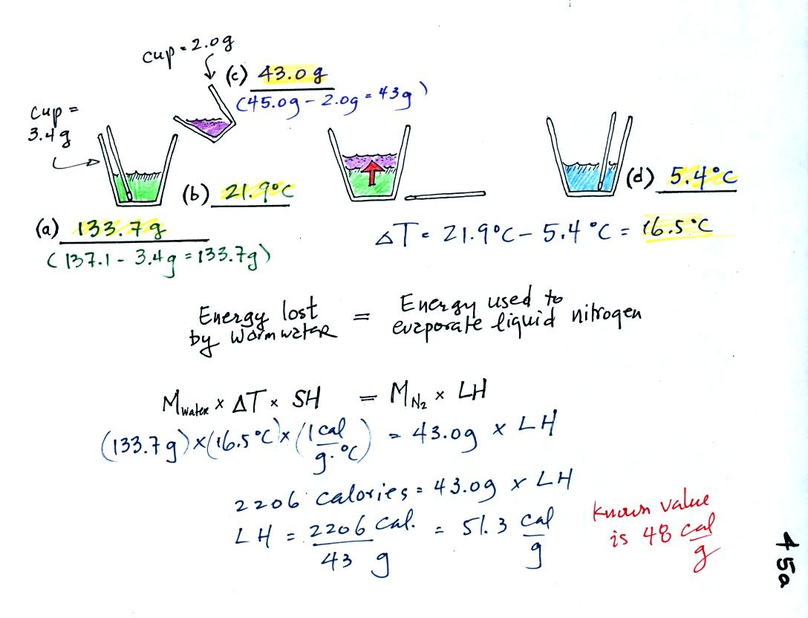

(a)
Some room temperature water poured into a styrofoam cup weighed 137.1 g. The cup itself weighed 3.4 g, so we have 133.7 g of water.
(b)
The water's temperature was 21.7 C.
(c)
43.0 g of liquid nitrogen was poured into the cup of water.
It takes energy to turn liquid nitrogen into nitrogen gas. The needed energy came from the water. This flow of energy is shown in the middle figure above. We assumed that because the experiment is performed in a styrofoam cup that there is no energy flowing between the water in the cup and the surounding air.
(d)
After the liquid nitrogen had evaporated we remeasured the water's temperature. It had dropped to 5.4 C. That is a temperature drop of 16.5 C.
Because we knew how much water we started with, its temperature drop, and water's specific heat we can calculate how much energy was taken from the water. That is the 2206 calorie figure above. This was used to evaporate 43 grams of liquid nitrogen. So we divided 2206 calories by 43 grams to get 51.3 calories needed per gram. That is our measured value of the latent heat of vaporization of nitrogen. A trustworthy student in the class informed us that the known value is 48 cal/g, so our measurement was pretty close.

Conduction is the first of four energy transport processes that we will cover. The figure below illustrates this process. A hot object is stuck in the middle of some air.
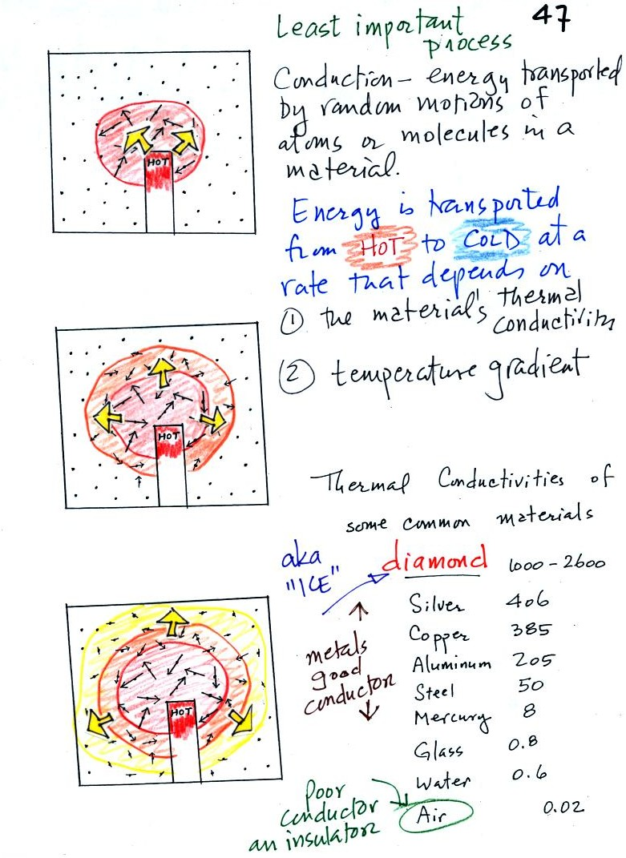

In the top picture some of the atoms or molecules near the hot object have collided with the object and picked up energy from the object. This is reflected by the increased speed of motion or increased kinetic energy of these molecules or atoms (these guys are colored red).
In the middle picture the initial bunch of energetic molecules have collided with some of their neighbors and shared energy with them (these are orange). The neighbor molecules have gained energy though they don't have as much energy as the molecules next to the hot object.
In the third picture molecules further out have now (the yellow ones) gained some energy. The random motions and collisions between molecules is carrying energy from the hot object out into the colder material.
Conduction transports energy from hot to cold. The rate of energy transport depends first on the material (air in the example above). Thermal conductivities of some common materials are listed. Air is a very poor conductor of energy. Air is generally regarded as an insulator. Water is a little bit better conductor. Metals are generally very good conductors (sauce pans are often made of stainless steel but have aluminum or copper bottoms to evenly spread out heat when placed on a stove). Diamond has a very high thermal conductivity. Diamonds are sometimes called "ice." They feel cold when you touch them. The cold feeling is due to the fact that they conduct energy very quickly away from your warm fingers when you touch them.
The rate of energy transport also depends on temperature difference. If the object in the picture had been warm rather than hot, less energy would flow or energy would flow at a slower into the surrounding material.
Transport of energy by conduction is similar to the transport of a strong smell throughout a classroom by diffusion. Small eddies of wind in the classroom blow in random directions and move smells throughout the room.. For our demonstration we used curry powder.
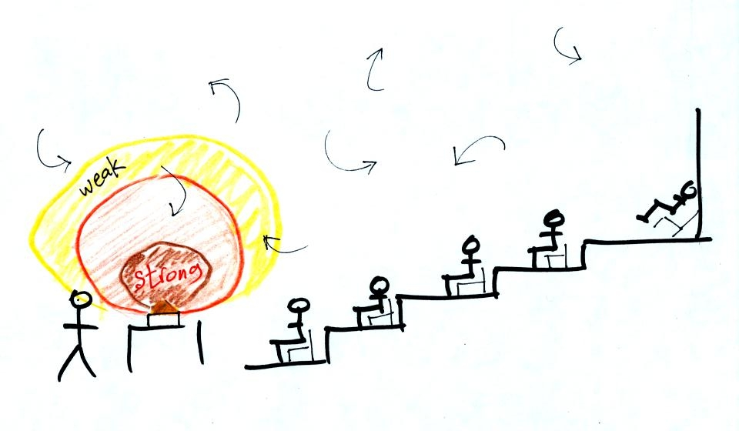

The curry powder was actually placed on a hot plate.
With time the smell should have spread throughout the room.
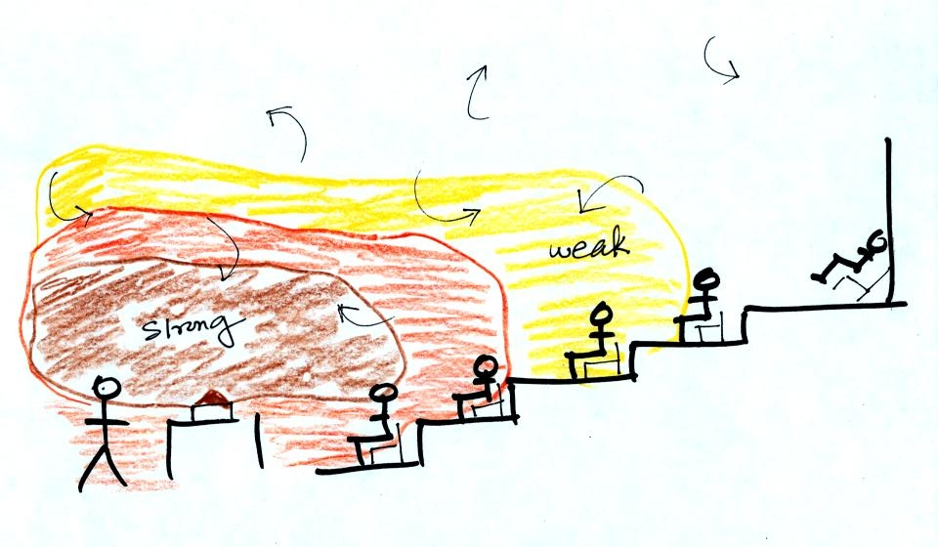
By the end of class some students in the back of the room said they could detect just the faintest hint of the curry smell.

