NATS 101 Sect. 2 Name_______________________________
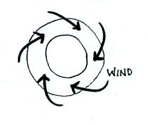
Optional Assignment

1. Does the figure show SURFACE or UPPER LEVEL
winds? Are these SOUTHERN or NORTHERN
hemisphere winds blowing around a center of HIGH
or LOW pressure?

2. The strength of the frictional force depends on the wind speed and also on the

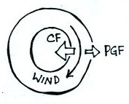
3. Does a hurricane’s direction of SPIN or direction of MOTION change when you move from the northern to the southern hemisphere?

4. The direction of the PGF in the figure at right
tells you this is a center of HIGH LOW pressure.
The direction of the Coriolis force (CF) is to the
RIGHT LEFT of the wind which means that this
is a NORTHERN SOUTHERN hemisphere map.
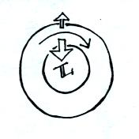

5. Is the inwardly pointing force in the figure at
right the PRESSURE GRADIENT or the CORIOLIS
force? Is this a NORTHERN or SOUTHERN
hemisphere chart?

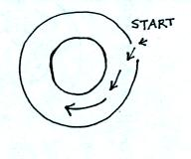
6. The direction of the initial motion in the figure at
right means this is a center of HIGH LOW
pressure. Rather than going straight toward the center
of the picture, the wind starts to turn toward the left.
The direction of this bending indicates that this is a
NORTHERN SOUTHERN hemisphere chart.

8. In the figure below (showing surface winds in the 3-cell model of the earth’s global scale circulation pattern), you would expect to find a belt of low pressure at
a. A b. B c. both A and B d. neither A or B

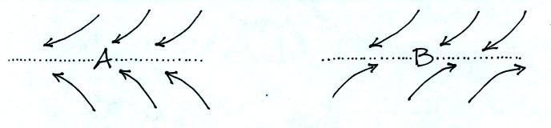
Would you expect to find wind PATTERN A or PATTERN B at the intertropical convergence zone (ITCZ)? Where in the 3-cell model would the other pattern of converging winds be found?

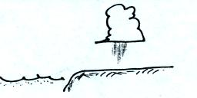
9. You would expect to observe showers as shown
in the figure at right during the DAY NIGHT
when the land WARMER COLDER than the sea.

10. Sinking air inhibits cloud formation. You would therefore expect to find clear skies and infrequent rainfall in the vicinity of the belts of HIGH LOW pressure found at _______ and _______ latitude in the 3-cell model (fill in the blanks with 0º, 30º, 60º, or 90º )

11. You observe a large storm system moving from east to west and spinning in a clockwise direction on a satellite photograph. This would most likely indicate a (circle 3 choices below)
a. Northern hemisphere b. middle latitude c. anticyclone
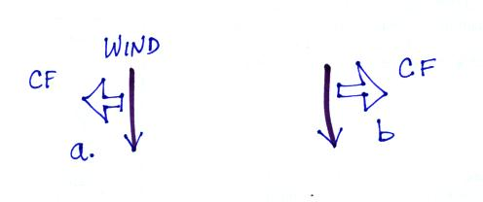
d. Southern hemisphere e. tropical f. cyclone

12. Which figure at right shows the direction of the Coriolis Force (CF) in the southern hemisphere?

13. Rising air motions are produced by surface centers of HIGH LOW pressure in the northern hemisphere and by surface centers of HIGH LOW pressure in the southern hemisphere.

14. What characteristics do the "doldrums" and the "horse latitudes" have in common?

15. The "roaring forties" and the "ferocious fifties" refers to strong EASTERLY WESTERLY surface winds found at MIDDLE SUB-TROPICAL latitudes in the NORTHERN SOUTHERN hemisphere.

