ATMO/ECE 489/589 Topics Summary for the Final Exam
(this summary picks up where the Mid Term summary left off)

Mar. 1 Sequence of events in negative cloud-to-ground lightning and basic characteristics of those processes. Positive cloud-to-ground flashes and upward, “triggered” lightning

Mar. 3 Multiple stroke flashes, number of strokes in a flash and interstroke interval, multiple ground strike points, continuing current that follows some return strokes & “hot” lightning. Rocket triggered lightning

Mar. 22 Lightning currents. Peak current and current derivative amplitudes, overvoltages produced across resistive and inductive loads. Charge transfer and action integral. Measuring currents. Lichtenberg figures, magnetic links, Rogowski coil, coaxial shunt.
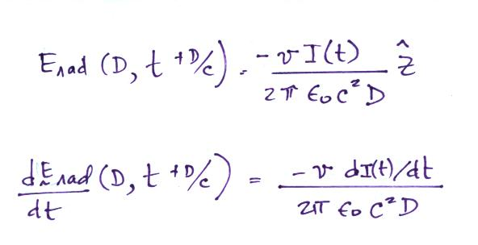
Mar. 24 E & B fields radiated by lightning.
E field consists of electrostatic, induction, and radiation field terms. Bruce-Golde and Transmission line models.

Mar. 29 Experimental tests of the transmission line model

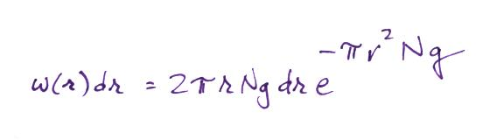
Mar. 31 Nearest neighbor probability density function

Apr. 5 Lightning protection of structures. 45 or 60o cone of protection for objects less than 50 ft. tall. Rolling sphere method for taller objects (sphere radius = striking distance). Air terminal, down conductor, and grounding rod. Are multiple grounding rods better than a single grounding rod. What is a counterpoise?

Apr. 7 Lightning protection of electronics. Topological shielding. Blocking and shunt impedances, clamping and crowbar devices. Gas discharge tube, metal oxide varistors.

Apr. 12 Lightning locating systems. Magnetic direction finding. Uses VLF signals and locates return stroke ground strike points.

Apr. 14 National Lightning Detection Network currently uses sensors that combine magnetic direction finding and time-of-arrival techniques.
VHF time of arrival maps out channel development in the cloud.

Apr. 19 Satellite detection and location of lightning (during the day and at night). How is the lightning optical signal detected against the strong daytime reflected sunlight background signal?

Apr. 21 Fast time resolved spectroscopy is used to determine peak lightning channel temperature and pressure. Thunder. The variety of the sounds heard and the duration of thunder depend on the orientation of the channel relative to the observer. Ground based optical measurements of lightning. Peak optical power emitted by lightning.

Apr. 26 Photodiodes. Average return stroke channel radiance per unit length. There won’t be any questions on:
Upper atmosphere luminous phenomena caused by lightning: sprites (high amplitude positive CG discharges), elves, and blue jets.
because I haven’t gotten the notes online.

