ATMO 170A1 Sect. 1 Name____________Answers______________
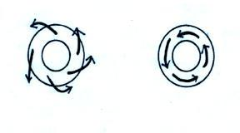
In-Class Optional Assignment

1. Does the RIGHT figure or the LEFT
figure show surface winds? Are the surface
winds shown in the figure NORTHERN or
SOUTHERN hemisphere winds? Are the
surface winds in the figure blowing around
a center of HIGH or LOW pressure?
Surface winds blow across the contour lines always toward low pressure. Since the winds are blowing outward in the figure above at left this must be a center of High pressure. The winds are spinning counterclockwise. That is what you expect to see around centers of High pressure in the Southern Hemisphere.

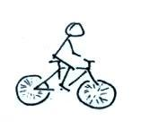
2. What happens if, when you’re riding your
bicycle along a flat level road you stop pedaling?
Would you continue to move in a straight line
at constant speed? If not, draw an arrow to show
the direction of the net force that would be
exerted on the bicycle. What is the name or
cause of this force?
After you stop pedaling, friction (points left in the figure, opposite the direction of motion) will slow you down and eventually bring you to a stop.
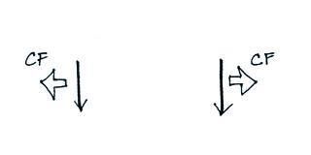

3. Circle the figure that shows winds blowing in the
southern hemisphere. CF stands for Coriolis force.
The right figure (CF to the left of the wind as you look downstream)

4. Does a hurricane’s direction of SPIN or direction of TRAVEL change when you move
from the northern to the southern hemisphere?
Hurricanes rotate counterclockwise in the Northern Hemisphere and clockwise in the Southern Hemisphere. They move from east to west in both hemispheres.

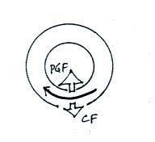
5. Does the figure at right show winds spinning around a
center of HIGH or LOW pressure? Is this a
NORTHERN or SOUTHERN hemisphere map?
PGF points inward so this must be a center of low pressure. The
Coriolis force is to the left of the wind meaning this is a Southern Hemisphere map.
6. Isaac Newton
a. invented calculus
b. discovered that white light is a mixture of different colors of light
c. formulated a law of gravitation d. formulated laws of motion
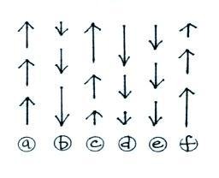
e. all of the above

7. The net force on ___c ___ and ___d ___
at right points upward. The net force on
___ a ___ and ___ e ___ is zero. The net
force on ___b___ and ___f___ points
downward. (the arrows show the direction
of motion, the length gives you an idea of
the speed)
Straight line motion at constant speed in Figs. a and e, that's zero net force. If you throw a ball upward it will travel upward a little ways then slow down and stop. It would then start to fall and pick up speed as it falls. That's shown in Fig. f and b, respectively. The downward pointing gravity force is responsible. That leaves Figs. c and d to show what happens when the net force points upward.

8. The direction of the _______ force changes direction when you move from the northern to the
southern hemisphere.
a. Coriolis b. frictional c. gravitational d. pressure gradient

9. Have you ever been to the southern hemisphere? If so, where?
Many students have been to Australia and parts of South America. I hope you checked the sinks and toilets when you were there.

10. The net force exerted on an object moving in a circular path at constant speed
a. points in the direction of motion
b. is zero
c. points inward toward the center of rotation
d. points outward away from the center of rotation

11. Hurricanes don’t form at the equator because there isn’t any CORIOLIS GRAVITATIONAL PRESSURE GRADIENT force there.

12. The strength of the Coriolis force depends on wind speed and also on _latitude____________.

13. Working together the __PGF__ and the ___CF___ determine the direction and speed of upper level winds.
a. Coriolis force b. frictional force c. gravitational force d. pressure gradient force

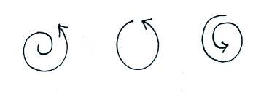
14. For each figure at right indicate
whether the net force is INward
OUTward or ZERO.
Inward forces in all three cases, just different amounts of inward force

15. Does the figure below show a NORTHERN or SOUTHERN hemisphere middle latitude storm
