ATMO 170A1 Name_______________________________
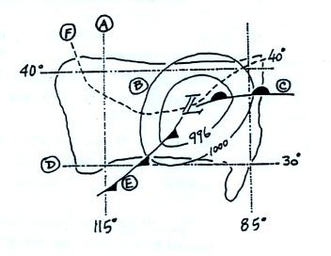
Optional Assignment

1. Find an example of each of the following
on the surface weather map at right.

line of constant latitude _______

isobar _______ warm front _______

cold front _______ isotherm _______

line of constant longitude _______

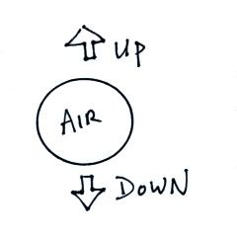
2. Pressure DECREASES INCREASES with increasing altitude in the atmosphere. Is the most rapid rate of decrease found at HIGH or LOW altitude?

3. Is the strength of the UPWARD or the DOWNWARD force
being exerted on the air parcel at right determined by the mass
of the air inside the parcel.

4. Before being plotted on a surface weather map,
the station pressure must be corrected for _______.
a. altitude b. latitude c. temperature d. time
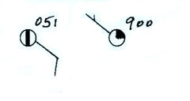
5. What are the actual sea level pressure values
plotted at right using the station model notation?

6. The large L symbol
that you often see on a surface weather map indicates a region of low _______
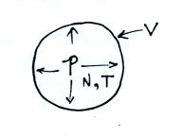
a. altitude b. air density c. air pressure d. air temperature

7. The ideal gas law equation shows the relationship between
the number (N), temperature (T), and pressure (P) of the
air molecules in a volume (V): P V = N k T
If N, V, and T were each to increase by a factor of 2 the pressure would
a. increase by 2 b. increase by 4 c. decrease by 2 d. decrease by 4
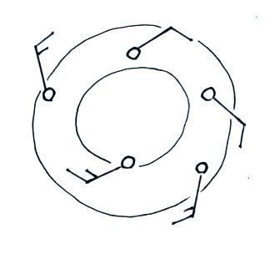
8. The winds in the figure at right are spinning in a
CLOCKWISE COUNTERCLOCKWISE direction
and are CONVERGING DIVERGING.

9. 14:00 GMT would be _______________ MST.

10. Is the 996 1000 1004 or 1008 mb isobar shown in the figure below?
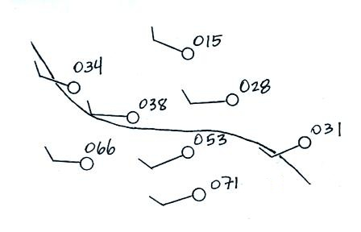

11. Which of the following does not cause rising air motions
a. cold front b. surface high pressure c. warm front d. surface low pressure

12. Show at right how the following weather observations would be plotted on a surface weather map using the station model notation
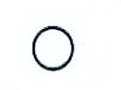
Temperature = 75º F cloud cover = 1/8
Pressure = 996.4 mb dew point = 57º F
winds: from the southeast at 15 knots
high altitude clouds: filaments of cirrus
weather: fair

13. Would you expect winds to be blowing from the northwest at POINT A or POINT B in the figure below? Would the fastest winds be found at POINT A or POINT B. Would you expect temperature at Point A to be WARMER or COLDER than at Point B?
