ATMO 170A1 Name_______________________________
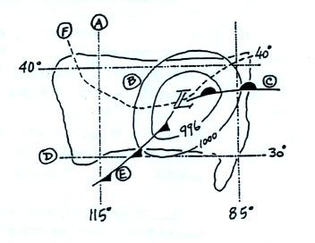
Optional Assignment

1. Find an example of each of the following
on the surface weather map at right.

line of constant latitude ___D___

isobar ___B___ warm front ___C___

cold front ___E___ isotherm ___F___

line of constant longitude ___A___

2. Pressure DECREASES INCREASES with increasing altitude in the atmosphere. Is the most rapid rate of decrease found at HIGH or LOW altitude?
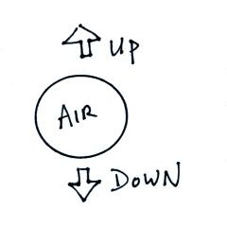
Pressure decreases most rapidly in the dense air at the bottom of the atmosphere.

3. Is the strength of the UPWARD or the DOWNWARD force
being exerted on the air parcel at right determined by the mass
of the air inside the parcel.
The downward force is just the weight of the air parcel. Weight
depends on the mass of the parcel.

4. Before being plotted on a surface weather map,
the station pressure must be corrected for _______.
a. altitude b. latitude c. temperature d. time

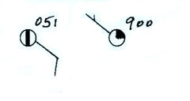
5. What are the actual sea level pressure values
plotted at right using the station model notation?
You need to add a 9 or a 10 and a decimal point to the
numbers plotted on the map.
The example at left could be 905.1 or 1005.1. You pick the value that is closest to 1000 mb. 1005.1 mb is the correct answer for the example at left.
990.0 mb is the correct answer for the answer at right.

6. The large L symbol
that you often see on a surface weather map indicates a region of low _______
a. altitude b. air density c. air pressure d. air temperature

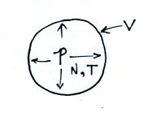
7. The ideal gas law equation shows the relationship between
the number (N), temperature (T), and pressure (P) of the
air molecules in a volume (V): P V = N k T
If N, V, and T were each to increase by a factor of 2 the pressure would
a. increase by 2 b. increase by 4 c. decrease by 2 d. decrease by 4
Increases in N and T increase Pressure. An increase in V decreases Pressure.
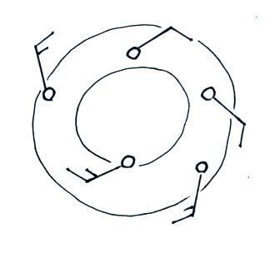
The increase is N and T increase Pressure by a factor of 4. But the increase in volume cuts that in half. Thus an overall increase of 2.

8. The winds in the figure at right are spinning in a
CLOCKWISE COUNTERCLOCKWISE direction
and are CONVERGING DIVERGING.

9. 14:00 GMT would be ______7:00 am ______ MST.
GMT is 7 hours later than MST. You need to subtract 7 hours.

10. Is the 996 1000 1004 or 1008 mb isobar shown in the figure below?
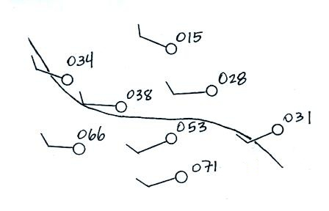

11. Which of the following does not cause rising air motions
a. cold front b. surface high pressure c. warm front d. surface low pressure

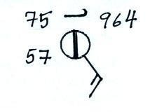
12. Show at right how the following weather observations would be plotted on a surface weather map using the station model notation
Temperature = 75º F cloud cover = 1/8
Pressure = 996.4 mb dew point = 57º F
winds: from the southeast at 15 knots
high altitude clouds: filaments of cirrus
weather: fair

13. Would you expect winds to be blowing from the northwest at POINT A or POINT B in the figure below? Would the fastest winds be found at POINT A or POINT B. Would you expect temperature at Point A to be WARMER or COLDER than at Point B?
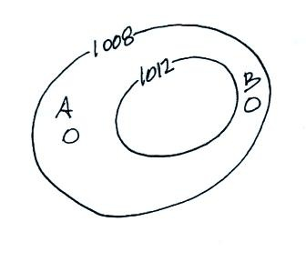

The values on the isobars indicate that this is a center of high pressure. The winds will blow clockwise and outward – from the southeast at Pt. A and from the northwest at Pt. B. The tightly spaced isobars at Pt. B indicate a strong pressure gradient which would produce faster winds than at Pt. A. Because winds at Pt. A are coming from the southeast they should be warmer than the northwesterly winds at Pt. B

