1. Can you think of any additional types/forms of energy?
There were a variety of answers to this question. Probably the most common answers were gravitational potential energy, chemical energy, and nuclear energy.

2. What's the difference between energy & power?
We have a pretty good intuitive feel for what energy is but it's hard to define. You need/use energy to heat and light your house. We eat food to provide the energy needed to stay alive. It takes energy to hike or pedal a bicycle.
Power is the rate at which energy is expended or consumed, energy/time. Watts are units of power
Watts = Joules/second
A thunderstorm has roughly the same amount of energy as an atomic bomb. There is a big difference in power however. It might take an hour for a thunderstorm to expend all its energy. An atomic bomb expends the energy is a few seconds.
3. The Gulf Stream is a well known ocean current. Where is it? What do you know about it? Is it a warm or cold current? What direction does it move? Can you see or appreciate how it is able to transport energy?
The Gulf Stream is a warm ocean current that flows from south to north along the east coast of the US. It then heads toward Europe and becomes the North Atlantic Drift current.
4. How is energy transported back and forth between the earth's surface and atmosphere?
I might have mentioned in class that this is was something of a trick question. Really all you need to do is list the 4 energy transport processes mentioned earlier in class: conduction, convection, latent heat, and electromagnetic radiation. They all transport energy back and forth between the earth's surface and the atmosphere.

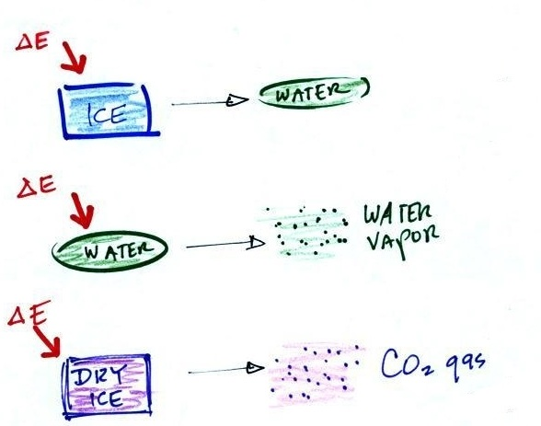

5. Can you name the three phase changes shown in the figure above.
From top to bottom they are melting, evaporation, and sublimation.

