ATMO 170A1 Optional Assignment Name_______________________________
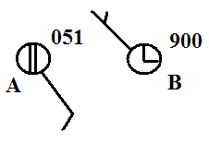
1. Decode the pressure data shown at right and.
determine whether CITY A or CITY B has
the highest sea level pressure value?

2. The atmosphere is split into layers (troposphere, stratosphere, mesosphere, etc.) according to how _______ changes with altitude.
a. composition b. density c. pressure d. temperature
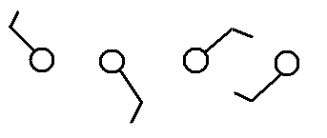

3. Circle the figure at right that shows winds
blowing from the southwest.

4. Would the 5 pm MST weather observations in Tucson be plotted on the 00Z 05Z 12Z or 17Z surface weather map?

5. Before being plotted on a surface weather map the measured station pressure must be corrected for
a. altitude b. latitude c. temperature d. time of day

6. Show at right how the following weather observations would be plotted using the station model notation.
temperature = 75º F cloud cover = 5/8
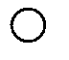
pressure = 995.4 mb dew point = 57º F
wind direction & speed = east at 20 knots
low clouds = stratocumulus clouds
high altitude clouds = filaments of cirrus clouds
present weather = dust or sand raised by wind
at the time of observation

7. The top of an average thunderstorm would be around ____________ kilometers tall
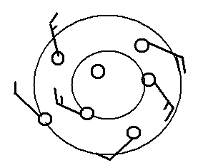
(fill in the blank with 1 10 100 or 1000)

8. Does the figure at right show winds blowing in a
CLOCKWISE or COUNTERCLOCKWISE
direction? Are the winds CONVERGING or
DIVERGING? Does the figure show a surface
center of HIGH or LOW pressure.

9. Which of the following would not cause rising air motions?
a. low pressure center b. high pressure center c. cold front d. warm front

10 The term cyclone is just another name for a center of HIGH LOW pressure.

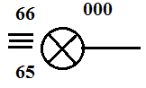
11. Use the weather data plotted at right to fill in the blanks
below (include the correct units, some of the information
requested below may be plotted in the figure at right)

temperature ____________ pressure ____________

altitude ____________ wind direction & speed ____________

sky cover ____________ dew point ____________ present weather ____________

12. The large L symbol that you usually see on a surface weather map indicates a region of
a. low altitude b. low air density c. low air pressure d. cold temperatures

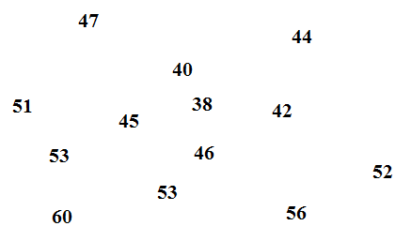
13. See if you can sketch in the 40º F and 50º F
isotherms on the figure at right.

14. Are clouds more likely to form when moist air COOLS or WARMS, when moist air RISES or SINKS?
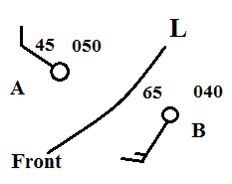
15. Weather conditions at two cities and a front are shown in the
figure at right. Would you expect the front to moving toward
CITY A or CITY B? Would this be a COLD or WARM
front.

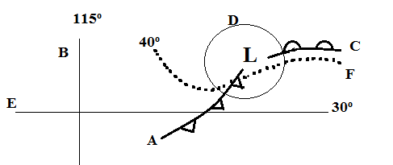
16. Find an example of each of the following
on the map drawn at right.

line of latitude__________
warm front __________
isotherm __________
cold front __________
isobar__________
line of longitude __________

