NATS 101 Upper Level Charts Name__________________________________
Optional Assignment
Choose (circle) one of the following options
Option #1: 0.5 pts of extra credit provided you Option #2: Points that you earn for answer-
make an honest effort to answer all the questions ing questions correctly will be added to your
& finish the assignment before coming to class overall score on the next quiz.

1. (1 pt) A copy of an actual upper level chart is shown below. A trough is found over the _______ of the US. The warmest weather would probably be found over the _______ of the US. (fill in the blanks)
a. eastern quarter b. western quarter
c. both the eastern & western quarters d. middle half or so
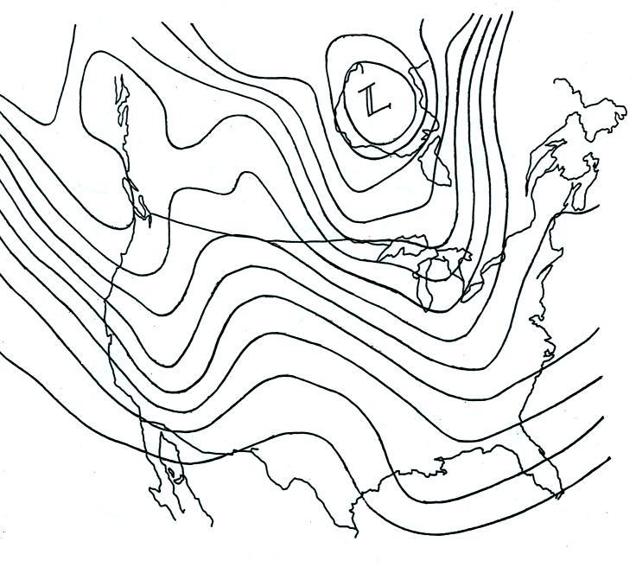

2. (1 pt) Generally speaking you will find PRESSURE HEIGHT contours on a surface weather map and PRESSURE HEIGHT contours on an upper level chart.
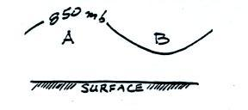
3. (1.5 pts) Points A and B in the figure at right (a crossectional view) are at the same altitude. The 850 mb pressure level is
shown. Point A lies below an upper level RIDGE
TROUGH. The pressure at A is HIGHER LOWER than
at B. The air at A is WARMER COLDER than at B.

4. (1.5 pts) Middle latitude storms (extratropical cyclones) form around surface centers of low pressure. Surface winds that blow around surface centers of low pressure always converge. Would this convergence cause the surface low pressure to get HIGHER or LOWER? . In order for a surface storm to strengthen the low pressure at its center must get HIGHER LOWER. In an intensifying middle latitude storm, would you expect to find that upper level winds are DIVERGING or CONVERGING?
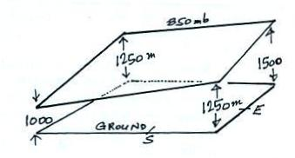

5. (1 pt) Which of the four maps below correctly depicts the inclined surface shown at right?

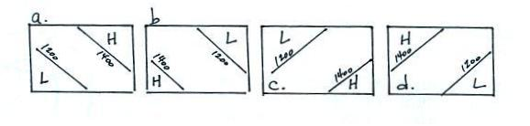

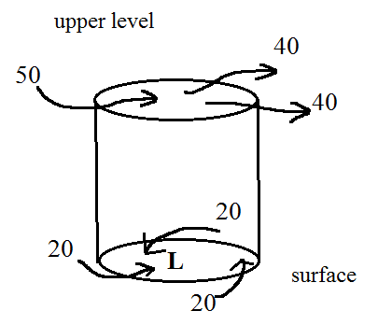

6. (2 pts) The upper level winds shown in the figure at right are
DIVERGING CONVERGING. Based on the relative amounts
of air moving into and out of the cylinder at right would you expect
the surface center of low pressure to get LOWER, remain the
SAME, or get HIGHER

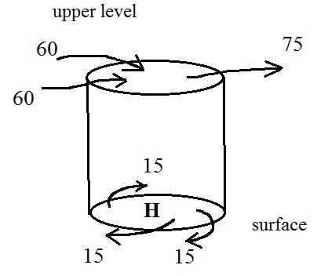

7. (1 pt) Based on the relative amounts of air moving
into and out of the cylinder at right would you
expect the surface center of high pressure to get
LOWER, remain the SAME, or get HIGHER

8. (1 pt) Low pressure and converging winds are found at the bottom center of a hurricane. You would expect to find HIGH LOW pressure and CONVERGING DIVERGING winds at the top of a strengthening hurricane. (see pps 42c&42 d in the ClassNotes packet for help with this question if necessary)

